USER GUIDE

CF-H906 User Guide

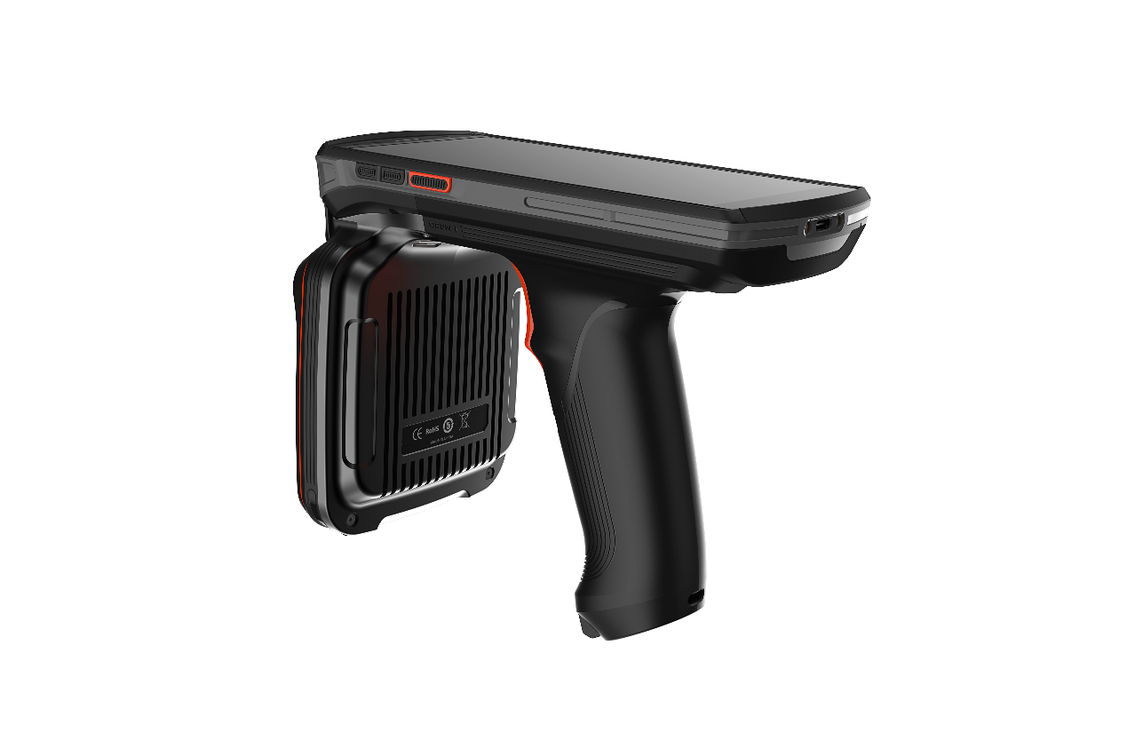

Table of Contents

About the Guide 4

Chapter I Getting Started 5

Introduction 5

Unpacking 5

Installation Guide 7

Caution on Battery Charging 8

Charging Method 9

Access Device Settings 9

Key Mapping 10

Display 15

Screen Brightness Settings 15

Screen Rotation Settings 16

Screen Wallpaper Settings 16

Sleep Settings 17

Font Settings 17

Sound Settings 18

Storage 20

Battery Management 22

Battery Optimization 22

Date and Time Settings 22

About phone 23

Upgrading 24

Chapter II How to Use 25

Introduction 25

Home Screen 25

Status Bar 26

Quick Access Panel 26

Usage of Touchscreen 27

App Profile 27

Task Manager 29

Restart 30

Power-off 31

Restore Device 32

Description of Computer Connected Operation 33

Disconnection from PC 38

Chapter III Data Capture 40

Introduction 40

Scan Settings 40

Chapter IV Wireless 56

WLAN 56

WWAN 58

Bluetooth 59

Chapter V RFID-UHF 62

RFID SCAN 62

Read/Write 63

Lock 63

Kill 65

PARAM 66

Chapter VI Maintenance and Troubleshooting 68

Introduction 68

Maintenance 68

Troubleshooting 69

# About the Guide

Introduction

This Guide offers information on usage of CF-H906mobile computer and its accessories.

Note: The screens and windows described in this Guide are samples, which can differ from actual ones.

Software version

To determine the software version of the current device, please touch**Settings** -**System**-**About Device**.

Android Version——display operating system version

Version No.——display software build version number.

Chapter description

This Guide covers the following topics:

* **Getting Started** offers information on puttingCF-H906 into operation for the first time.
* **How to use** is an operation instruction on CF-H906.
* **Applications** describes usage of built-in apps.
* **Data Capture** describes acquisition of bar code information by scanning.
* **Wireless** describes different wireless data communication methods.
* **RFID-UHF** describes information about UHF operation..

Sign convention

The following convention applies in the text:

Bold:

* Emphasis
* Title
* Dialog box, window, part name, and screen icon
* Keyword
* Button name

(●):

* Operational option
* Order list
* Step list needed, which may not be continuous

(√):

* Functional option

Italic:

* Marked emphasis

Relevant Document

* CF-H906 Brochure
* CF-H906 Specification

# Chapter I Getting Started

### Introduction

This chapter describes product information and instruction of device for the first time.

### Unpacking

1. Please carefully remove all the protective materials around CF-H906 and keep the device case for storing and transporting the device in the future

2. Please check the following elements:

* CF-H906 intelligent terminal×1
* Adapter×1
* USB cable×1

3. Inspect the device for damage. If any equipment is damaged or missing, please contact the customer service support or local distributor.

4. Please remove the screen shipping protective film before using.

#### Appearance introduction

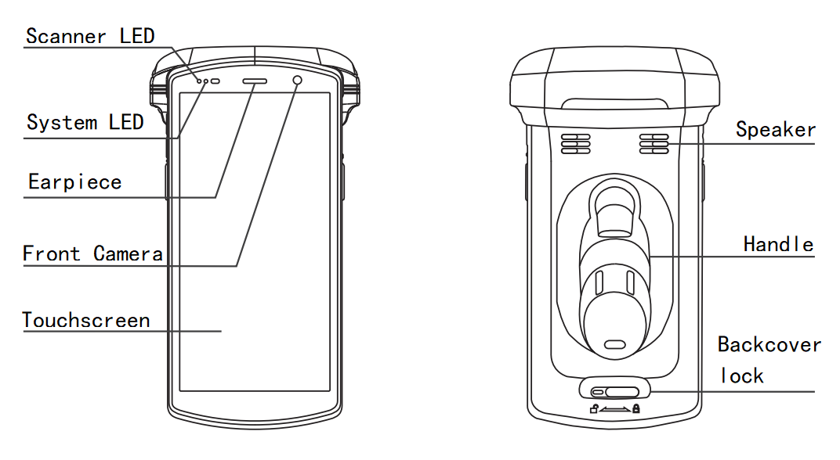

Figure 1-1 Front and Bottom View

#### Side

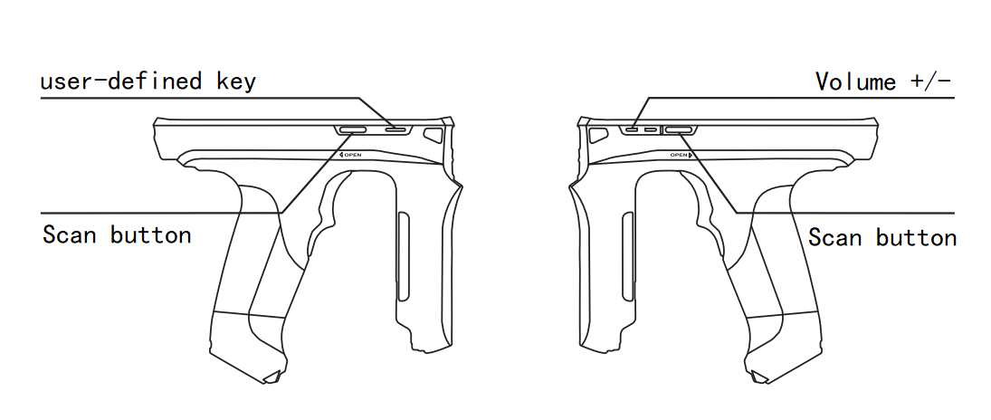

Figure 1-2 Right View Figure 1-3 Left View

#### Back

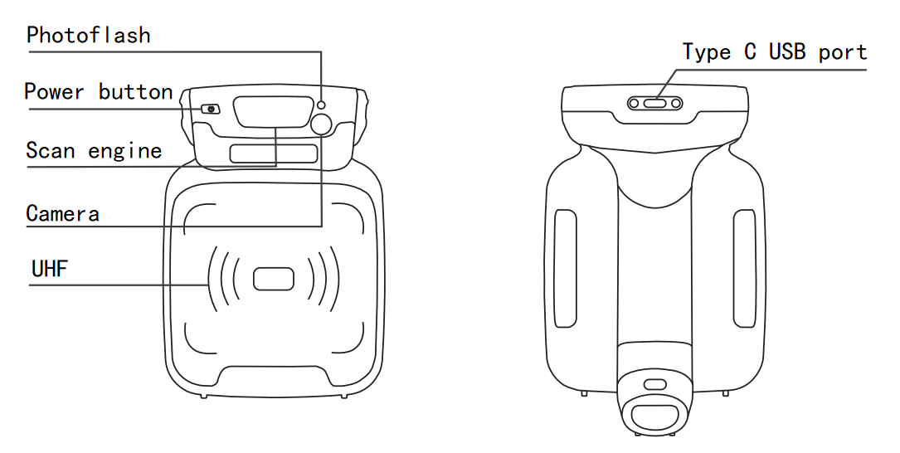

Figure 1-4- Front and BackViews

### Installation Guide

* The SIM card slot is in the battery holder.

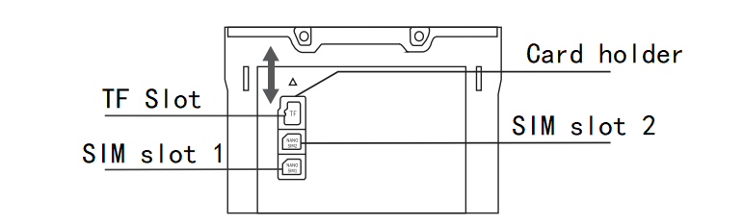

Figure 1-5CF-H906 Card Slot

#### Instruction on SIM/TF Card installation

Take out the SIM/TF Card holder on the left of shell and correctly put SIM Card 1, SIM Card 2 and TF Card in the card slot;

#### Note:

1. Both SIM Card 1 and SIM Card 2 are Nano SIM Cards;

2. The preferred network is provided by SIM Card 1:

1) Card 1 and Card 2 are carried by China Mobile/China Unicom/China Telecom. If the VOLTE HD voice call function is enabled for China Telecom 4G cards, both cards will be available for 4G network in display; otherwise, the China Telecom card will be the additional card available for the 2G network in display;

2) Given that both Card 1 and Card 2 are carried by China Telecom, if the VOLTE HD voice call function is enabled for China Telecom 4G cards, the carrier of Card 1/Card 2 will be shown as China Telecom; otherwise, the master card will be available for 4G network while the additional card will have null signal in display.

#### Instruction of battery

While installing the battery, please note the direction of installing the battery. Load the front end of the battery in the device's battery slot and push the bottom of the battery into the device. Please do not push the battery into the device with force. The installed battery in the battery holder should be flat and secure. The installation method is as shown in Figure 6

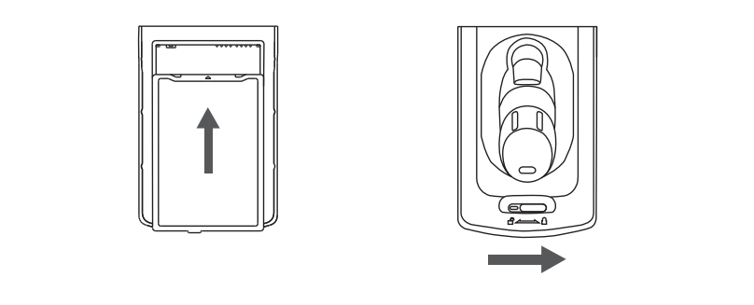

Figure 1-6 Battery Installation

#### Instruction of battery replacement

1. Long press the power key and a dialog box will pop up;
2. Select power-off;
3. Upon power-off, remove the battery cover;
4. replace the battery with a new one.

### Caution on Battery Charging

1. Please do not use or charge the device in any environment with too high or low temperature;

2. Please charge the battery by the product's charger in standard configuration or desktop charger only;

3. If the device (including the battery) is not used for the moment, please separately store the battery and device and pack them in PE bags or other insulated bags in the original package in case that they become damp or contact with other electronic devices. Do not store the unpacked battery in a stack;

4. Please do not idle the device for over 3 months; be sure to charge and discharge the battery not used for the moment once per 3 months, where the stored battery should be 60%～70% charged (i.e., 3.8V～3.9V);

5. The lithium battery should be stored somewhere cool, dry and ventilated. It is advised to be stored in a 0～28℃ environment.

### Charging Method

#### Charge by USB

For TYPE-C USB cable, link one end to computer or apdaterand the other to device. In charging, the device's charge indicator is red, which will turn green when the device is fully charged.

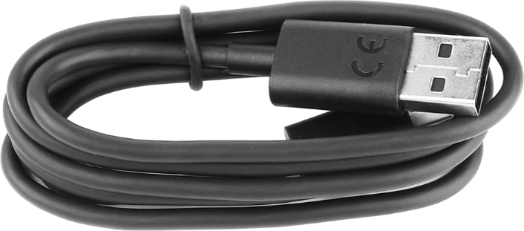

Figure 1-7 TYPE-C USB Cable

### Access Device Settings

Method 1

Open the quick access panel and touch the settings icon;

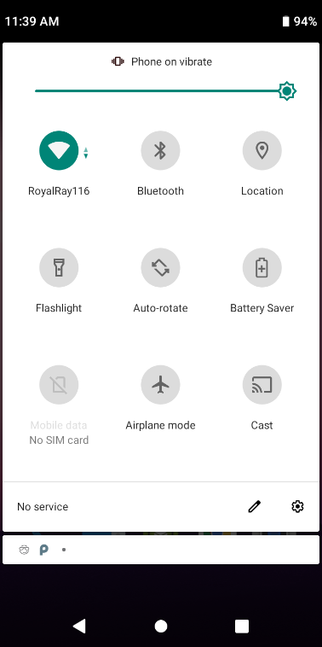

Figure 1-8 Quick Access Panel

Method 2

In the homescreen, pull up the screen and touch the settings icon;

Figure 1-9 Enter Settings Interface from home screen

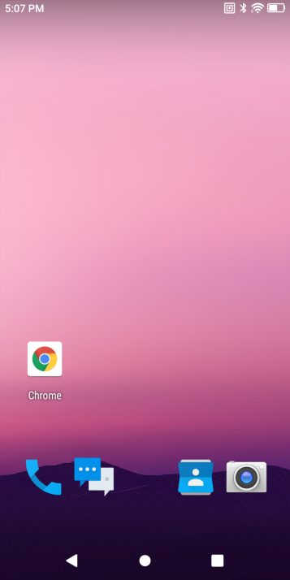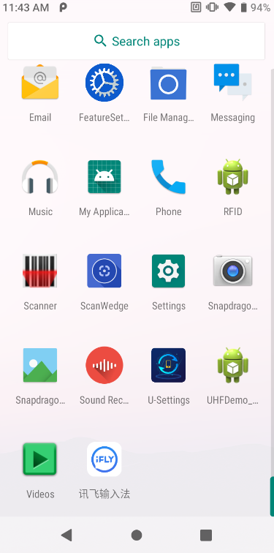

### Key Mapping

Key mapping applies to all the physical keys except the power key. Each mapped key can be granted with a new key value.

Steps for key mapping:

1. Open **Settings**-**System**-Remap **Key** and check –**Enable intercept Key**;

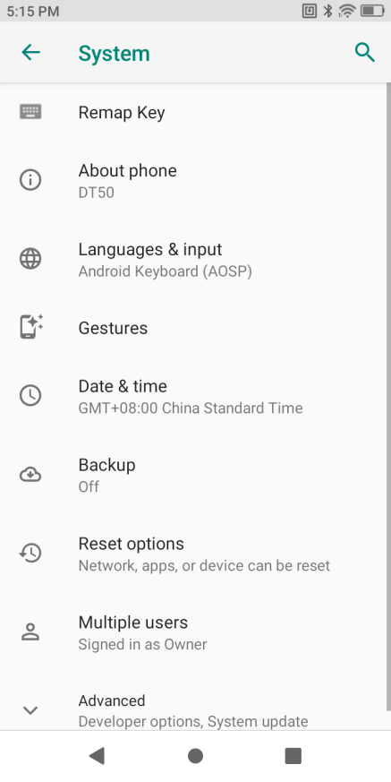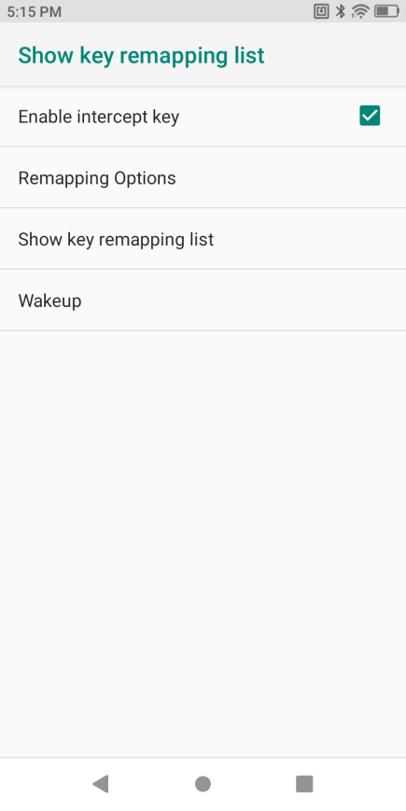

Figure 1-10 Key Mapping

1. Touch **ReMappingOptions**;

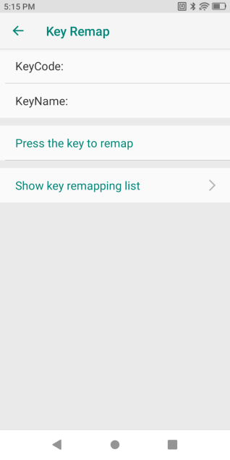

Figure 1-11 Mapping Function Enabled

1. Press the physical key for key mapping, the key value and name will be shown;

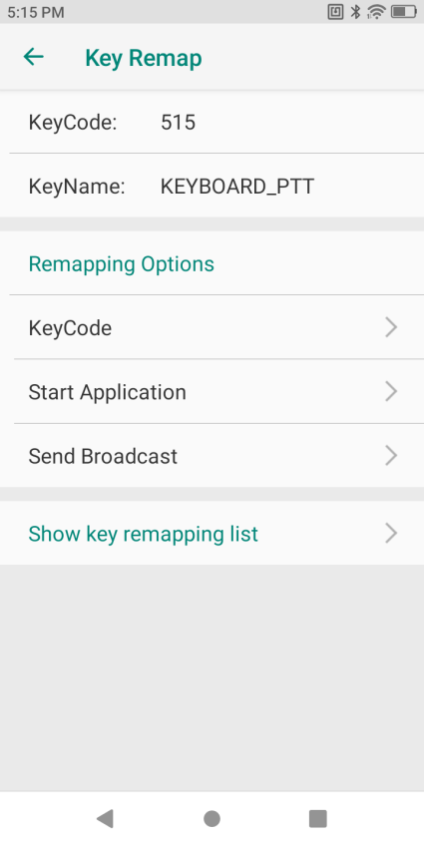

Figure 1-12 Mapping Function

1. Tap**Mapping Function**-**Replace by a New Key**, **Enable an App** and **Send a Broadcast**.

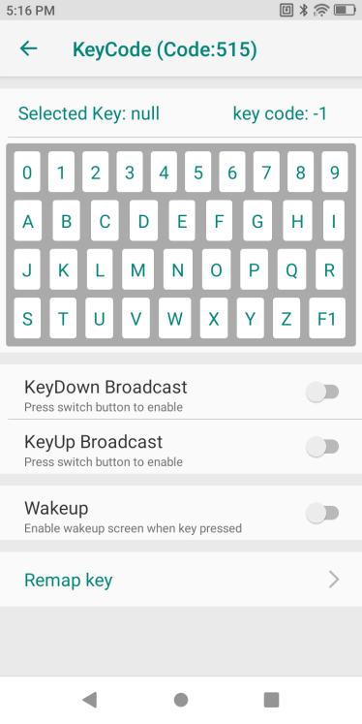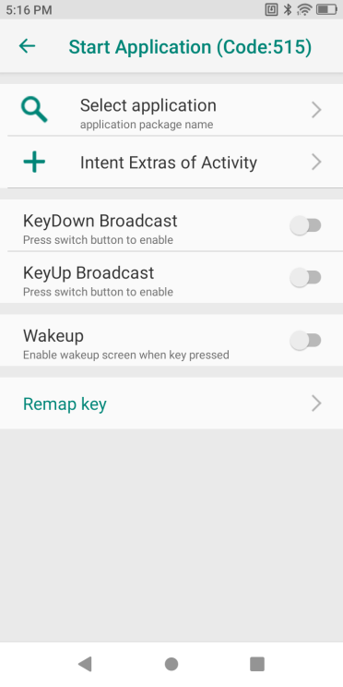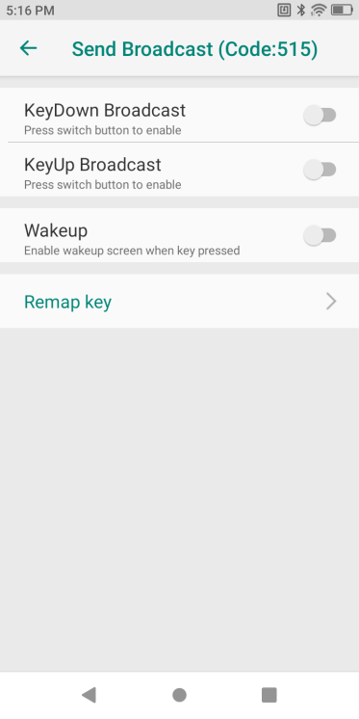

Figure 1-13 Mapped Key Value

1. Tap**Mapping Key**-**Enable Key Mapping**.
2. View the mapped key list in the key mapping page to manage mapped keys.

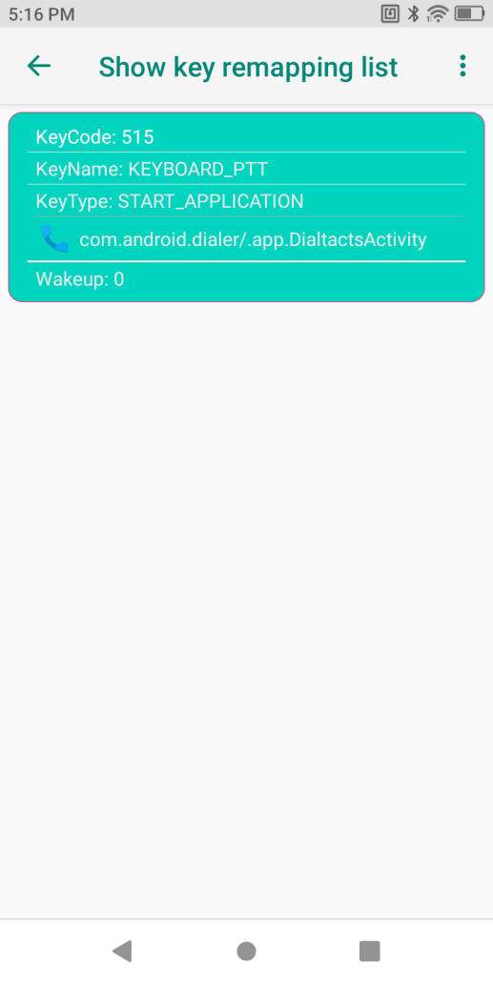

Figure 1-14 Mapped Key List

* 1. Slide a certain option in the list to the left to reset the key to the default settingsand clear the key's mapping value;

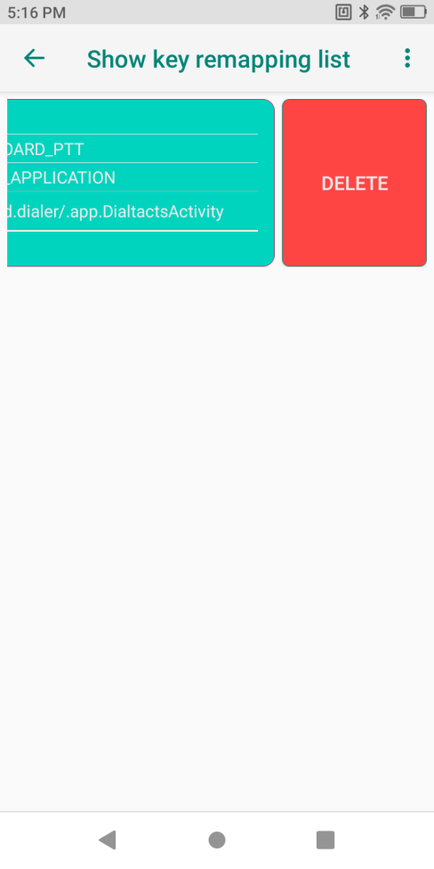

Figure 1-15 Key Mapping Deleting

* 1. Touch the menu key or settings icon at the top right corner to reset the value of each mapped key and restore the default value of each physical key.

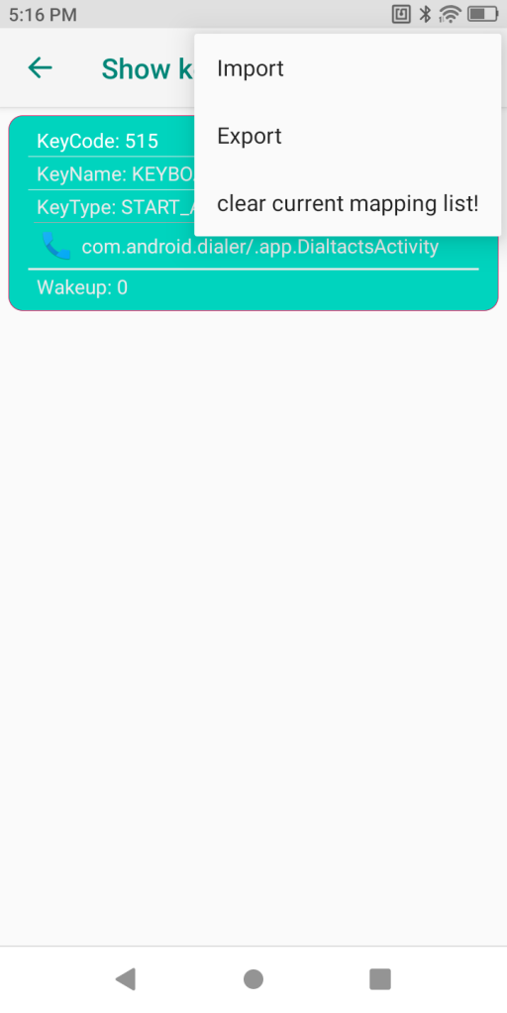

Figure 1-16 Mapped Key Resetting

### Display

Display settings include settings of brightness, night mode, wallpaper, screen rotation, sleep time and font among other functions.

### Screen Brightness Settings

Manually set brightness:

1. Pull down the status bar to open the quick access panel;
2. Move the brightness control icon to alter brightness level.

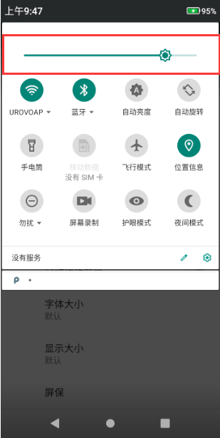

Figure 1-17 Brightness Control

### Screen Rotation Settings

By default, screen rotation is disabled. To enable screen rotation:

a) Pull down the status bar and click the screen rotation icon;

b) Check Settings-Display-Auto Screen;

* Keep the current orientation: lock the orientation;
* Orientation of screen rotation: rotate subject to screen content

Note: rotation is not available for the homescreen interface.

### Screen Wallpaper Settings

a) Tap**Settings**-**Display**-**Wallpaper** to replace the wallpaper;

b) Long press the blank in the home screen to replace the wallpaper;

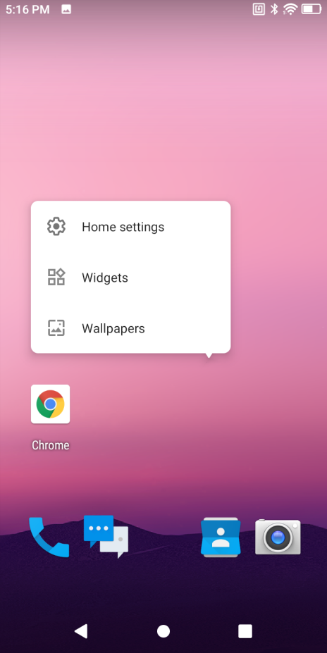

Figure 1-18 Wallpaper Replacing

### Sleep Settings

User may make CF-H906 sleep if not using it for a moment.

As CF-H906 is in the sleep status, user may directly press the power key to wake up the screen and unlock to back to the program interface. To make CF-H906 sleep, press the power key to turn off the screen or set sleep time.

1. Pull down the status bar to open the quick access panel;
2. Touch the settings icon to enter settings;
3. Open Display-Sleep
4. Select a sleep time
   * 15s
   * 30s
   * 1min (default)
   * 2min
   * 5min
   * 10min
   * 30min
   * Never

### Font Settings

The settings are concerned with alteration of size of each font.



Figure 1-19 Font

### Sound Settings

a) Press the volume key to regulate media volume settings. Slide up or down the volume icon to set the volume;

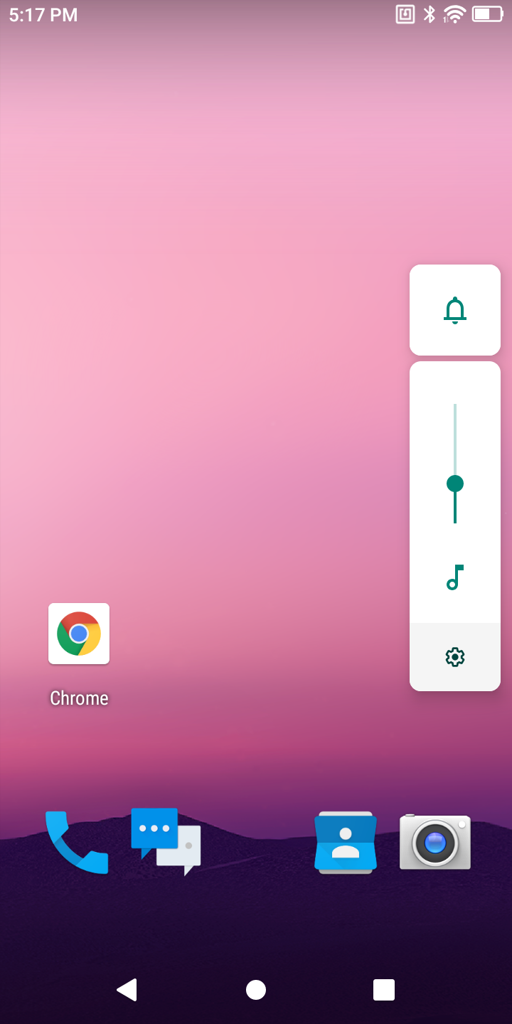

Figure 1-20 Media Volume Settings

b) Click the settings icon to open the sound settings interface for setting media volume, call volume, ringer volume, and alarm volume as well as ringtone, alarm tone, etc.;



c) Select Settings-Sound to open the sound settings interface for setting the media volume, call volume, ringer volume, alarm volume as well as ringtone, alarm tone, other notification tones, or vibration, etc.

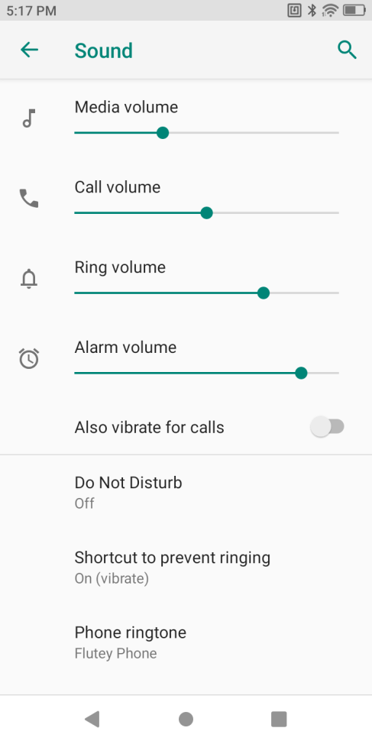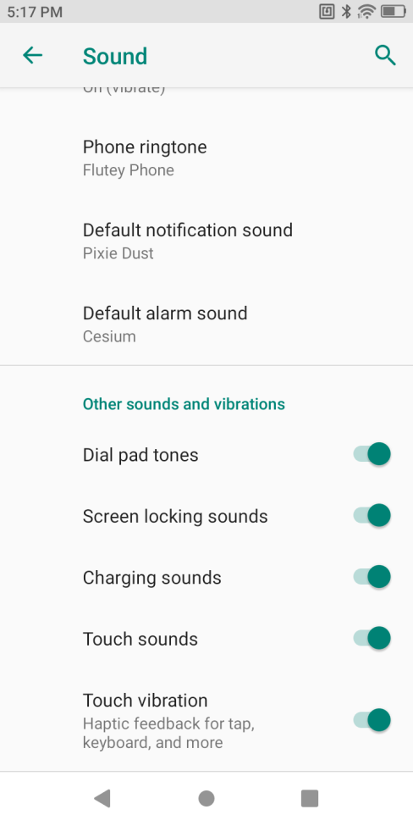

Figure 1-21 Sound Settings

### Storage

This function is to view internal space for storage. The system makes data statistics on files in the device type by type.

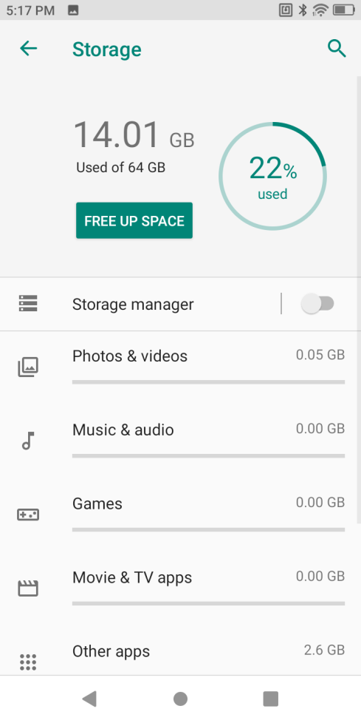

Figure 1-22 Details of Storage Space

The system makes classified storage management to facilitate users' view and management;

### Battery Management

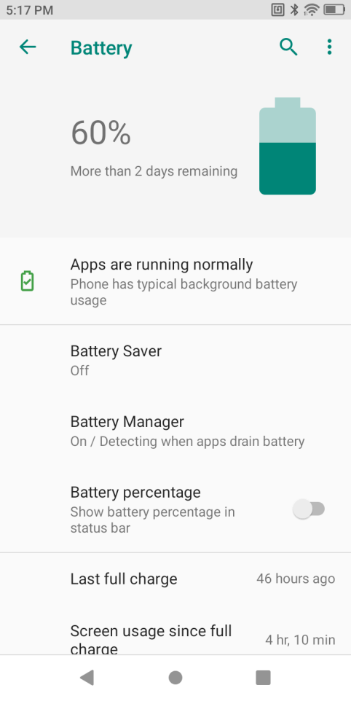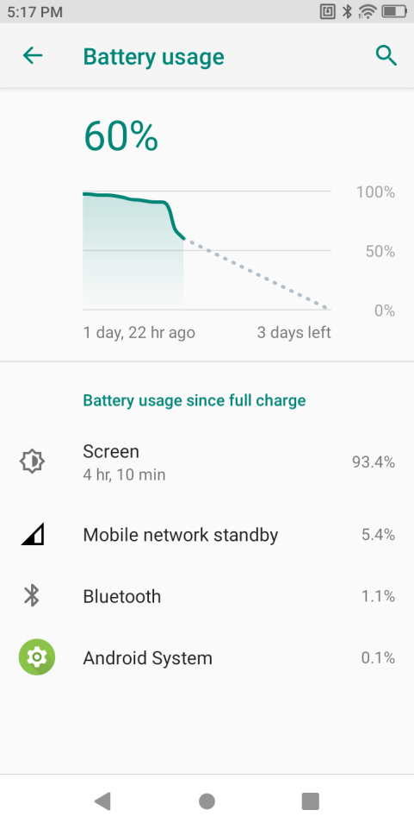

Figure 1-23 Battery Management Page

In Settings-Battery, users can view power usage, regulate or shut down apps for power control, and turn on the power saver mode at the top right corner.

### Battery Optimization

* Please follow the tips below to save the battery power:
* Set the screen to sleep after idling for a while. See Sleep Settings for details.
* Clear the background of all apps to enter the power-saving mode
* In Settings-Automatic On/Off, set CF-H906 to automatically power on/off.
* Reduce screen brightness.
* Turn off all the wireless connections not used for the moment. Touch the airplane mode. The airplane icon will be shown in the status bar, indicating that all the wireless connections are off.
* Turn off automatic updates of e-mail, calendar, contacts and other apps.

### Date and Time Settings

As CF-H906 is networked, the system will automatically update the time and date. Users need set the time zone only. If time is not updated, please check whether the device is networked or whether the current WLAN supports the network time protocol (NTP). Where manual settings are needed, please take the following steps:

1. Pull down the status bar, open the quick access panel and touch the settings icon;
2. Time and date;
3. Disable **Automatic Set Date and Time**;
4. Modify time and back.

l

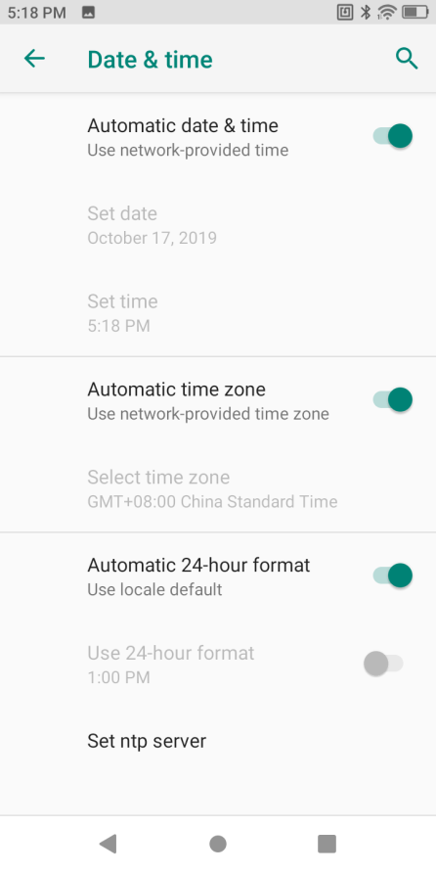

Figure 1-24 System Time Settings

### About phone

Open Settings-About phone to view information of this Terminal Device.

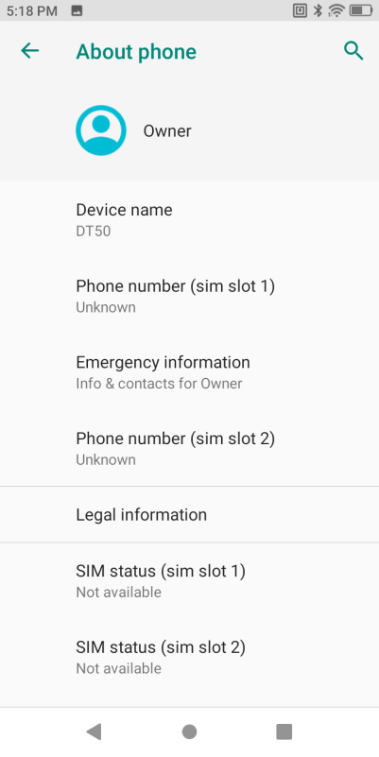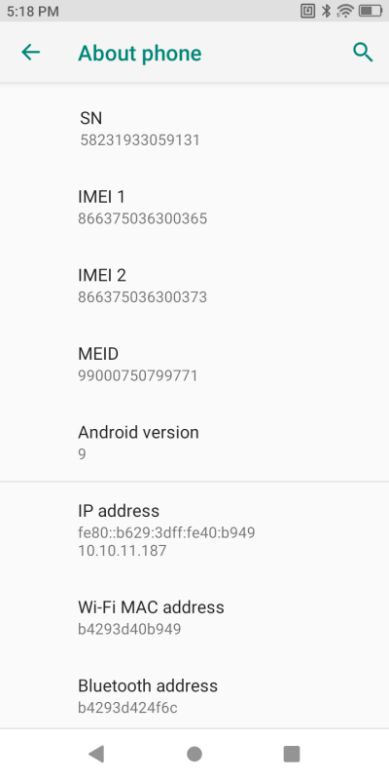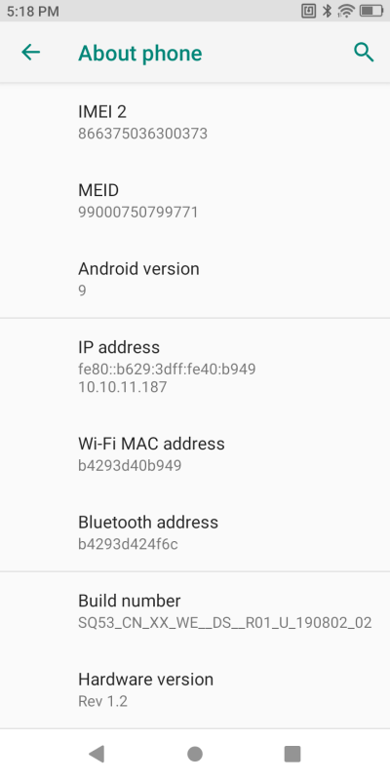

Figure 1-25About Device

SIM Card Status--view carrier, signal strength, IMEI and other information

SN--display the device's unique identifier--SN

Model and Hardware--view the device's model and SN

IMEI Information--view IMEI1, IMEI2 and MEID information

Android Version--view the device's Android version

IP Address--display the device's IP address

WLAN MAC Address——display the device's WIFI physical address

Bluetooth Address——display the device's Bluetooth address

### Upgrading

Local Upgrading--System-System Update-Select Local Updates

For local upgrading, please copy the upgrading zip package in the device before taking the preceding steps, select the upgrading package and following instructions for upgrading.

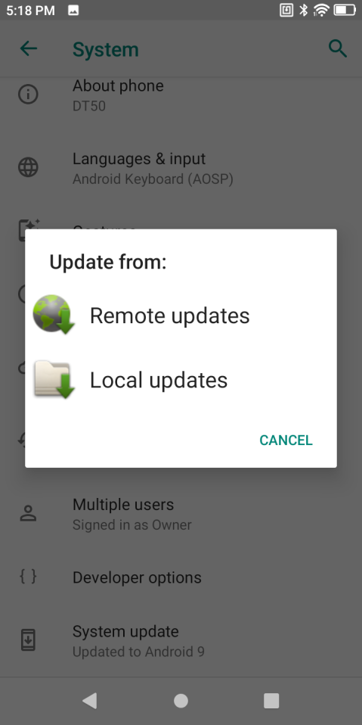

Figure 1-26 System Upgrading

Remote Upgrading--open **Settings**-**About Device**-**System Upgrading**-tap**Remote Updating**. For remote upgrading, please contact RoyalRay's technical support team.

For upgrading details, please contact RoyalRay'stechnical support team.t

# Chapter II How to Use

### Introduction

This chapter introduced buttons, status icons and control keys in CF-H906 and gives basic instructions

### Home Screen

Note: CF-H906 has updated editions. If you use updated editions, editions may vary from each other in some operations, which will depend on each real product.

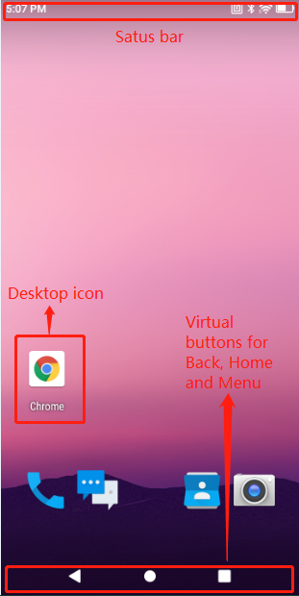

Figure 2-1 Home Screen Interface

### Status Bar



Figure 2-2 Status Bar

Status icon list

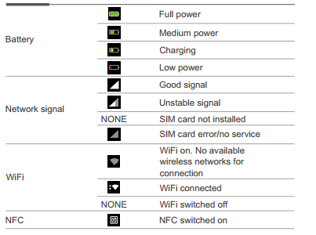

### Quick Access Panel

The quick access panel is for quick general settings. Given that this function is not off, users may pull down the status bar to open the panel. Touch the icon to quickly turn on or off this function

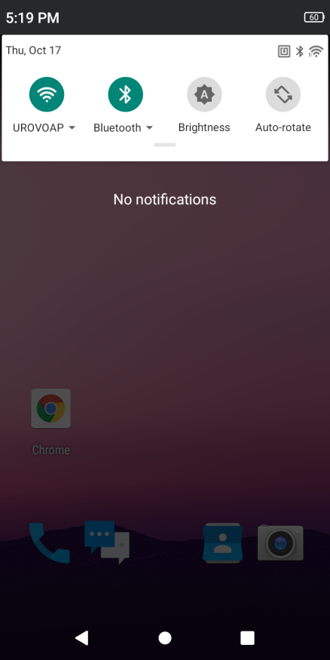

Figure 2-3 Control Panel

### Usage of Touchscreen

Use the multi-touch-sensitive screen to operate the device.

• Light touch - light touch to:

• Select any screen option

• Enter letters and signs in the screen keyboard

• Press any screen button.

• Light touch press and hold - light touch, press and hold to:  
Make any homescreen option move to a new position or be deleted.

• Create a homescreen shortcut for a certain App.

• Open the homescreen menu for user-defined homescreen settings.

• Blank out the homescreen till the menu is seen.

• Drag - light touch, press for a short time and hold a certain option, and finger the option in the screen to a new position.   
• Slide - slide to:  
Slide up/down or left/right in the app center interface to browse different app icons;

Slide in the lock-screen interface to set the unlocking pattern to unlock the screen.

• Long press - long press to:

Long press the homescreen to call the MENU function;

Drag any app or tool shortcut.

### App Profile

System apps are set forth in the following table.

|  |  |
| --- | --- |
| Icon | Description |
|  | **Scanner** - test the engine module of the scanning head |
|  | **Chrome** - access the network. |
|  | **Calendar** - view and manage calendar events. |
|  | **Camera** - take photos and record videos. |
|  | **Calculator** - provide basic and scientific calculating functions. |
|  | **Clock** - set the alarm and timer. |
|  | **Contacts** - manage contact information. |
|  | **Email** - receive and send e-mails. |
|  | **File Manager** - organize and manage all the files in the device. |
|  | **Messaging** - receive and send SMS and MMS. |
|  | **Phone** - dial a phone number for voice communications. |
|  | **Settings** - configure CF-H906. |
|  | **FeatureSettings** - help users complete general settings not included in system settings |
|  | **Recorder** - record audio files. |
|  | **Vid**eos - play video files stored in the device or microSD Card. |
|  | **Music** - play audio files stored in the device or microSD Card. |
|  | **AutoInstallApps**- set automatic installation of all apps in the default directory |
|  | **AppMarket** - download apps defined in the cloud management platform |

#### How to access apps

Installed apps will be shown in the app center interface, except for ones in the background,

1. In the homescreen, pull up the screen to enter the app center interface;

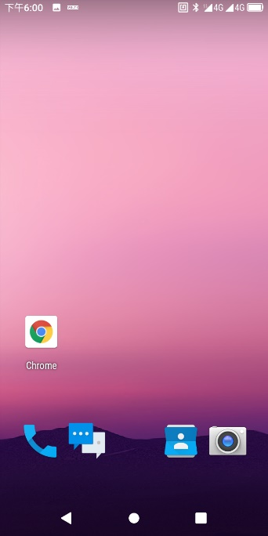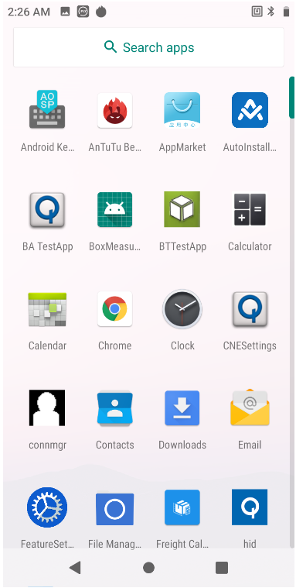

Figure 2-4 Enter App Center from Main Interface

1. Slide left or right to view more app icons and touch any app icon to be accessed to open the app.

### Task Manager

1. Tap the menu key on the right and a list in the following figure will be shown;

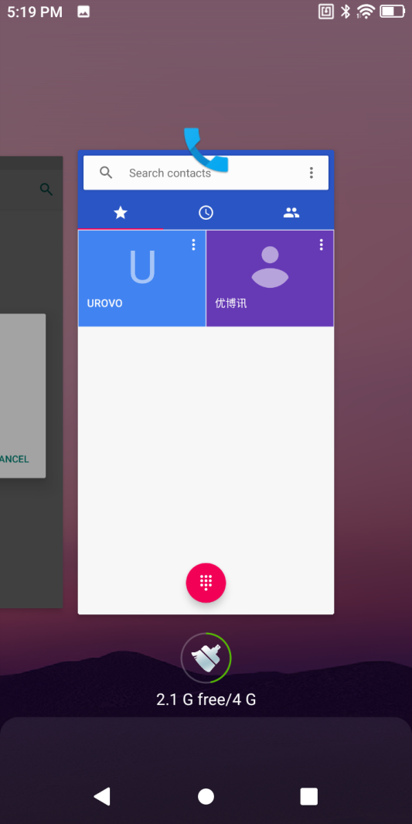

Figure 2-5 Task Manager

1. Slide left or right the screen to find any app accessed lately;
2. Slide up or down to clear apps lately accessed from the background;

### Restart

1. If an app stops responding, long press the power key for hot reset;

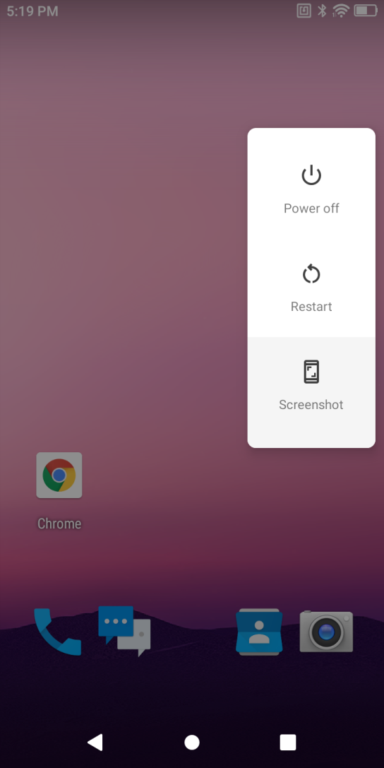

Figure 2-6 Restart

### Power-off

1. Long press the power key and wait for a popup dialog box;
2. Tap the power-off option.

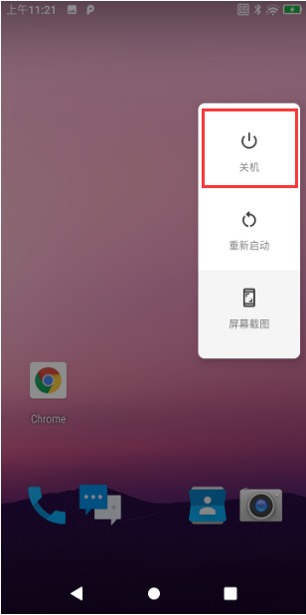

Figure 2-7 Power-off

### Restore Device

**Restore Device** is a built-in restoration toolkit that enables users to initialize the system. Attention! Please copy and save important files before resetting! Restoration will erase all the user data!

1. Pull down the status bar to open the quick access panel;
2. Tap the settings icon to enter **Settings**-**System**-**Reset options**;
3. Select:

* Reset Wi-Fi, mobile Data Network and Bluetooth
* Resetapp preferences
* Erase All Data (factory reset)

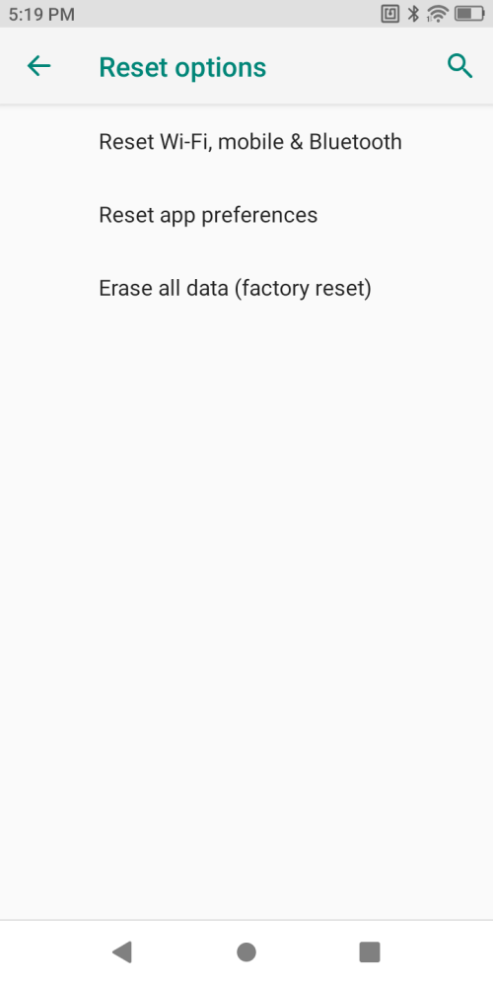

Figure 2-8 Reset

### Description of Computer Connected Operation

If Android system driver or Android mobile assistant is installed in your personal computer (PC), you may connect the device to the PC via the device's USB cable. (You can download the preceding software from the official website or any other website)

After installing the preceding software, insert one end of the device's USB cable to the device and the other to the PC's USB port to connect the device to the PC, press and hold the top of screen at any interface of the device and pull down to enter the USB settings interface:

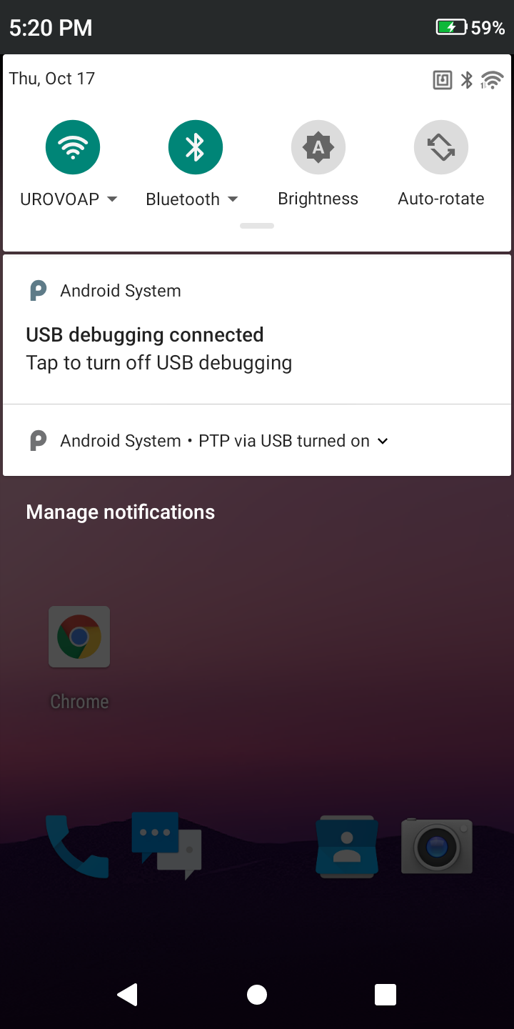

Figure 2-9 Connection Option

After the device is connected to PC, a USB enabling popup will be shown. Tick "Allow this computer for debugging" and select "OK" and this popup will not be seen when the device is connected to the PC next time.

Enable USB Debugging to enter the debugging mode

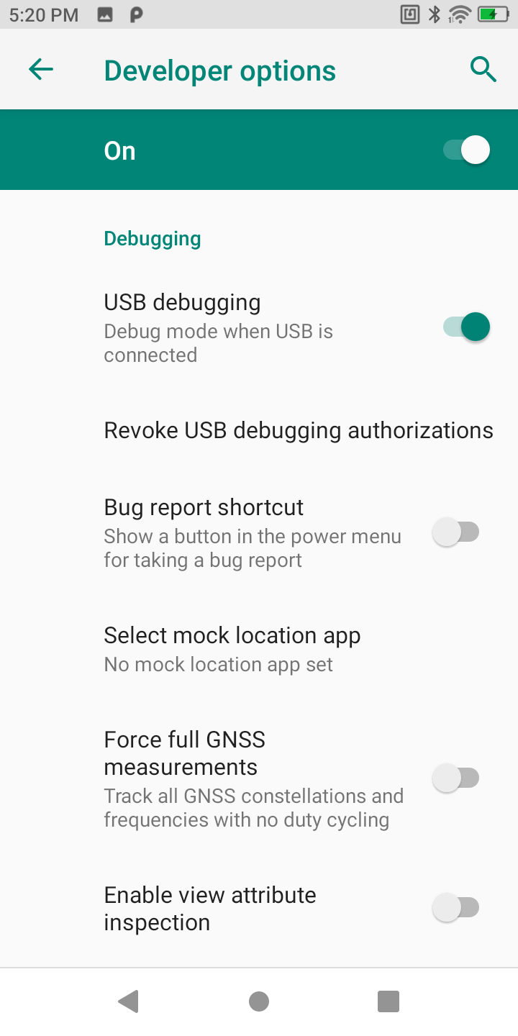

Figure 2-10 USB Debugging

Open any removable disk and users will view the memory device, transfer and save data at Windows PC→My Computer.

#### File management by media transfer protocol (MTP)

1. Connect the device to PC by a USB cable;
2. Pull down the status bar to open the notification panel. Select "File Transfer" in USB Purpose to transfer media files to Windows or transfer files by any Android file transfer app to Mac (please refer to www.android.com/filetransfer).

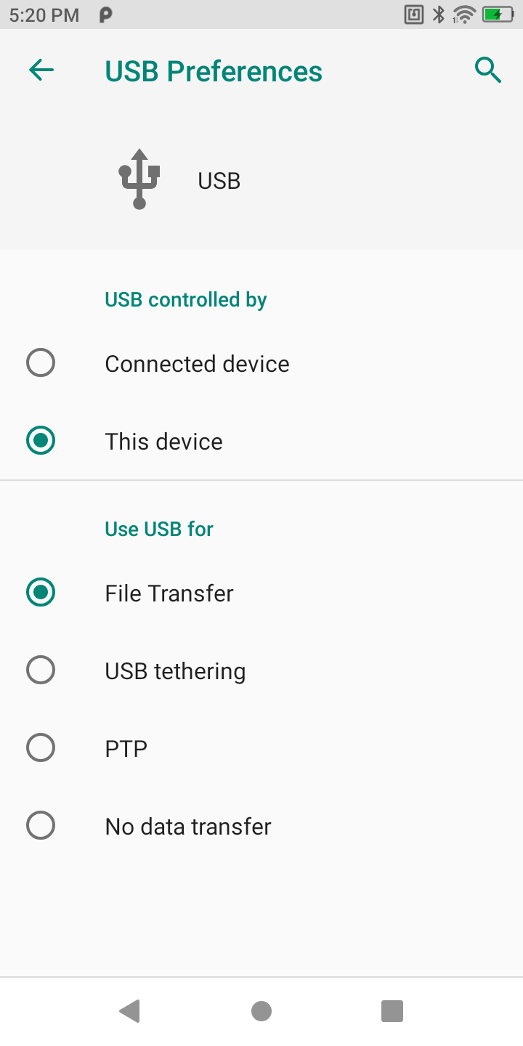

Figure 2-13 File Transfer

1. At PC end, open My Computer to access CF-H906 device;



Figure 2-14 File Transfer Shown at PC end

1. Open an internal storage folder or SD card folder;
2. Manage media files needed.

#### Picture management by picture transfer protocol (PTP)

1. Connect the device to PC by a USB cable;
2. Pull down the status bar to open the notification panel and select **PTP** in **USB use for** to transfer photos to Windows.

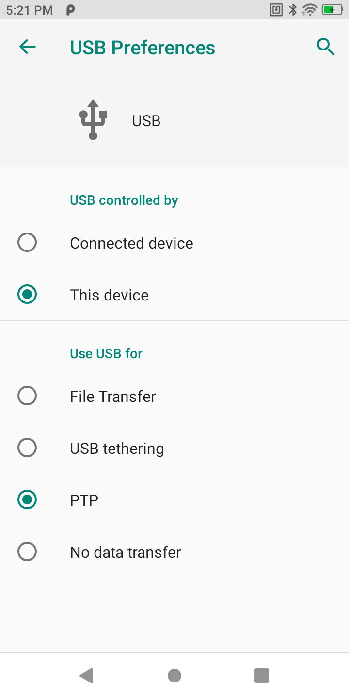

1. PTP
2. At PC end, open My Computer to access CF-H906 device;



Figure 2-16 PTP Shown at PC end

1. Open an SD card folder or internal storage folder;
2. Manage picture files needed.

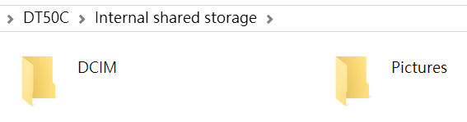

Figure 2-17 PTP Folder Shown at PC

#### SD Card mounting

In this mode, no microSD Card directory folder will be shown at PC end until a microSD Card is inserted into PC.

#### Charging mode

1. Connect the device to PC by a USB cable;
2. Pull down the status bar to open the notification panel and select "No Data Transfer" in USB Purpose;

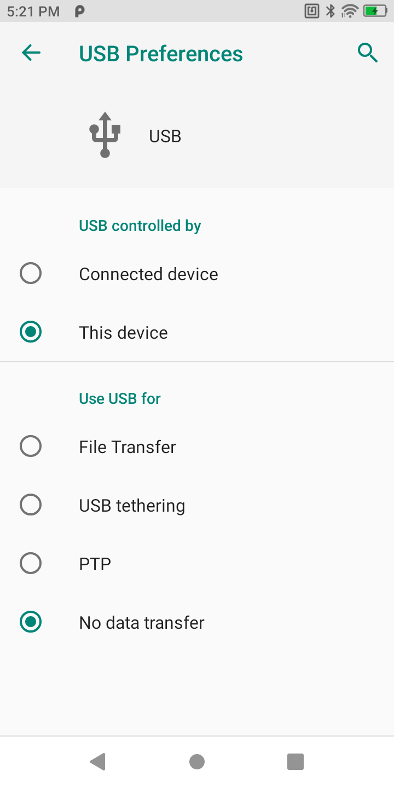

Figure 2-18 Charging Mode

1. In the charging mode, data communication is not available

### Disconnection from PC

Caution: Please safely unplug the device as instructed at PC before removing the USB cable in case of loss of data.

1. Find the external device identification in the task bar at the bottom right corner of PC;
2. Right click to select **Unplug CF-H906 Device**
3. Carefully remove the USB cable.

# Chapter III Data Capture

### Introduction

CF-H906 supports data acquisition in the following methods

* Scan engine decoding

Scan engine

* + - 2D scan engine can read various 1D/2D bar codes and 360° read various bar code systems, including the most prevalent linear bar code, postal code, PDF417, QR, DATAMATRIX, etc.
    - By scanning techniques, 2D scan engine takes a photo for a bar code, saves the generated image in memory, and executes a top software decoding algorithm to extract bar code data from the image.

### Scan Settings

Scanning heads may differ from each other in the settings interface. N6603 is taken as example for illustration herein. For more details, please contact CHAFON technical staff for instruction.

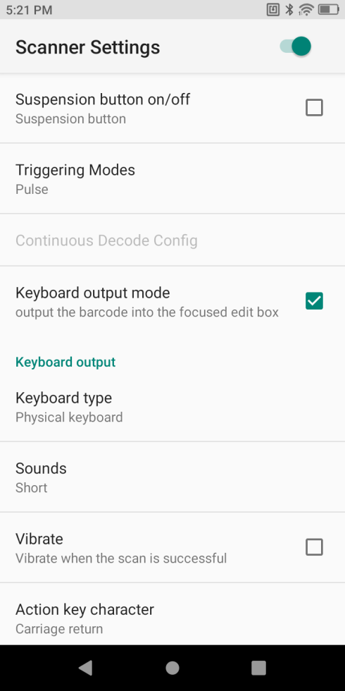

Figure 3-1 Scan Settings

* Floating action button

Open the virtual key scanning tool on the desktop--USCAN, which is available for dragging at will and touching to simulate the key scanning function;

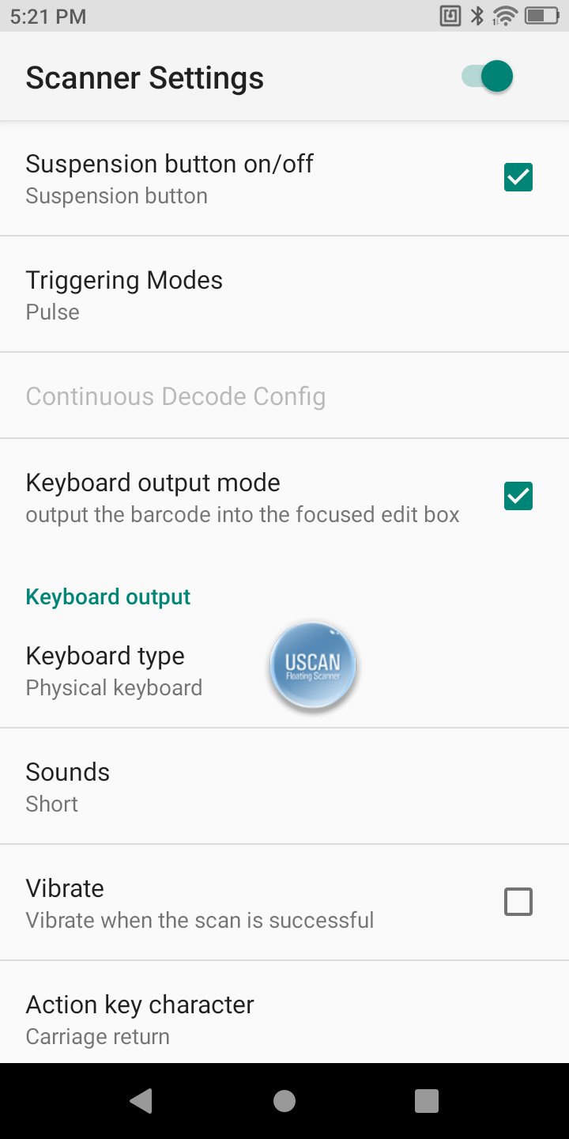

Figure 3-2 Floating Button Scanning Function

* Trigger mode
  + - * Auto mode - manually trigger the scanning function. Press the scanning key and laser light or supplementary light will be shown. The light will not go out until decoding is completed or scanning times out;
      * Continuous mode - manually trigger the scanning function. In the continuous scanning mode, the scanning laser or supplementary image light will not go out after decoding. Instead, decoding will sustain.
      * Manual mode - manually trigger the scanning function. Press the scanning key and laser light or supplementary light will be shown. Release the key and the light will go out. In addition, the scanning light will also go out after decoding;
* Output by keyboard

Check this mode and the scanning results will be output to the app focus edit box in the foreground by keyboard. Cancel checking this mode and output will be done by broadcast.

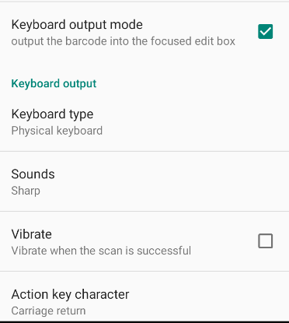

Figure 3-3 Scanning Output by Keyboard

* Keyboard Type - options include **Physical Keyboard**, **Software keyboard,Always Physical Keyboard** and**Always Software Keyboard**among others. Such options may cause a difference in scanning results. Please select with caution.

**Physical Keyboard** - If a focus input box arises in any app interface in the foreground, it will directly show all the data, otherwise the device will output scanning results character by character through keyboard simulation;

**Software Keyboard**: the device directly displays all the data in the input box through input method editor simulation;

**Physical Keyboard Only**: the device outputs scanning data through physical key event simulation at any interface;

**Always Software keyboard:** output through any non-Android input box, e.g., webpage or search box.

* **Sound** - set the system's notification tone for scanning, which may be None, Instant (default) or Squeak.
* **Vibrate** - check to enable the function of vibrating after scanning
* Operational Key Character - None, Carriage return, Line feed or Tab. Add operational key characters behind scanning results through keyboard simulation.

None: no operation.

Carriage return: add an enter behind scanning results through keyboard simulation;

Line feed: add an OK operation behind scanning results through

keyboard simulation;

Tab: add a Tab key operation behind scanning results through keyboard simulation;

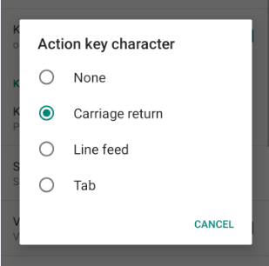

Figure 3-4 Operational Key Character

* Output by Broadcast

Cancel checking output by keyboard and output will be done by broadcast.

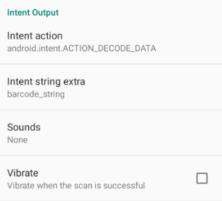

Figure 3-5 Output by Keyboard/Broadcast

Set broadcasting via a corresponding app to receive tag and motion data of the designated broadcast. If the scanned data match the app's broadcast tag and motion (tag and motion are editable), the data will be directly received by the Broadcast Receiver. Any intent transfer value may be separately output or handled in the background.

* Chinese code type

The Chinese code type is UTF-8 by default. This option needs to correspond to the Chinese code type of 2D codes. Any mismatch between the two may lead to code garbling. Please use this function with care.

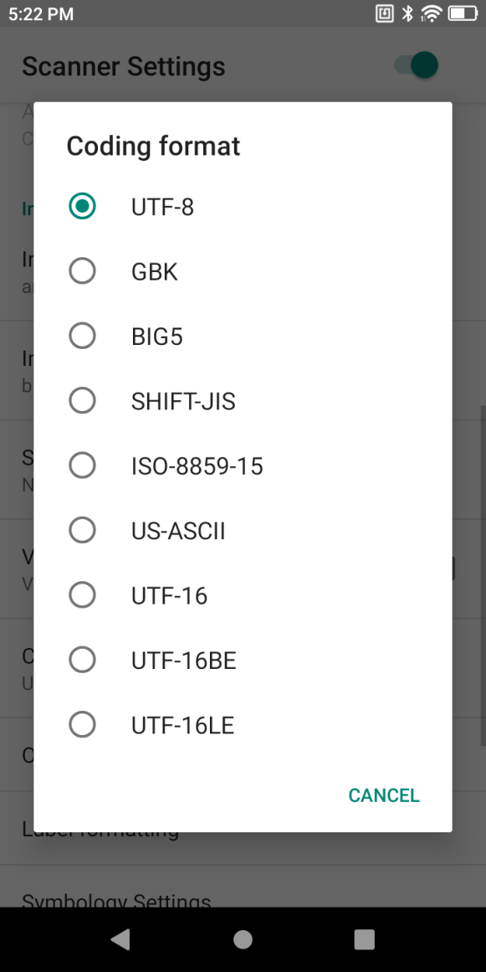

Figure 3-6 Chinese Code Type

* Other settings

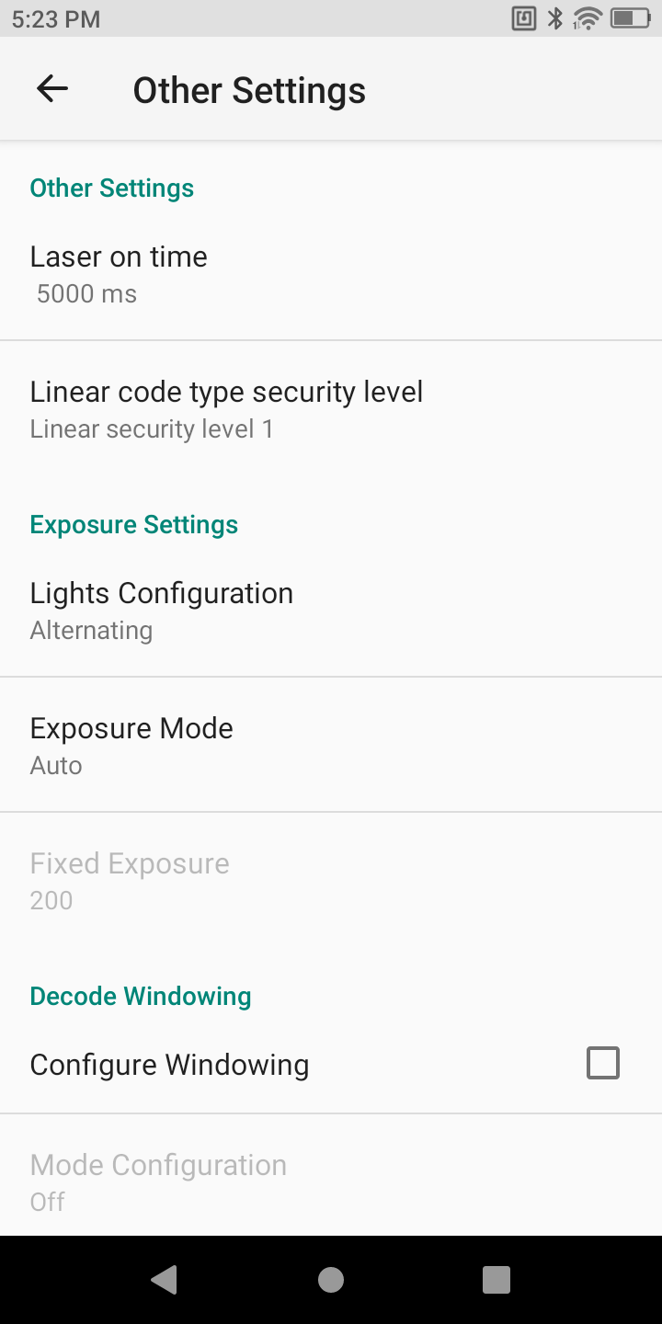

Figure 3-7 Other Settings for Scanning Head

**Laser on time** - laser duration for failing in single scanning, range of 500-9900 ms, 5000 ms by default;

**Linear code type security level** - set the check level to lower the error rate. The higher the level is, the more accurate it will be but the slower decoding per time will be;

* Exposure

**Lights Configuration**

Different scanning heads vary from each other in the settings. N6603 scan engine is taken as example for illustration.

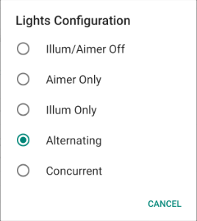

Figure 3-8 Fill Light Settings

* **Off**: turn off illumination / aimer light;

**Aim Light Only**: turn on aim light only;

**Illum Only**: turn onillumination only;

**Alternating**: turn on illumination and aim light in alternation;

**Concurrent** turn on illuminationand aim light at the same time;

* **Exposure Mode**: auto/on. In the auto mode, the scanning head may automatically regulate the exposure value; in the on mode, the exposure value can be set;
* **Fixed Exposure**: 1~600. The higher the value is, the brighter it will be;
* Decoding Windowing

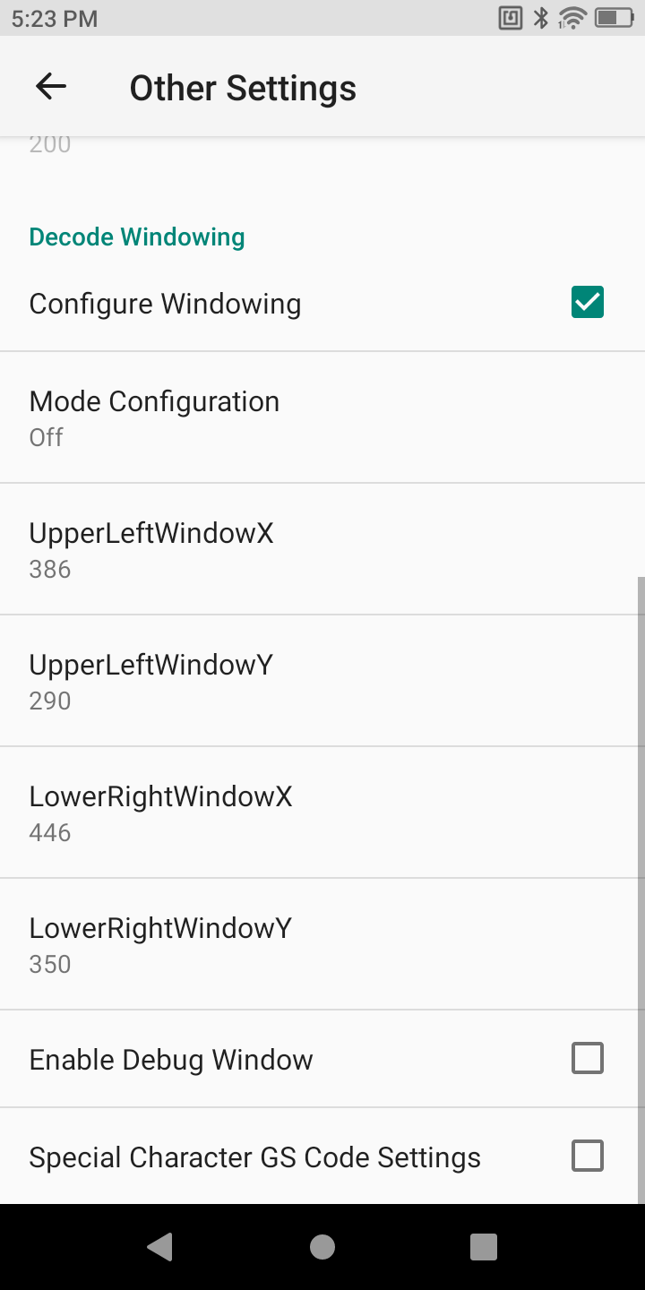

Figure 3-9 Decoding View Finder Settings

* Configure Windowing - set the range of bar codes from any photo taken;
* Mode Configuration - Off, Around, Aimer, or Field of View. To fit the view finder, select the Aimer mode;
* UpperLeftWindowX
* UpperLeftWindowY
* LowerRightWindowX
* LowerRightWindowY
* Special Characters GS Code Setting - check to operate (substitute) special characters in the GS code;
* Label formatting

Upon access of bar codes, the system may be available for additional functions: Formatting, Prefix, Suffix, Formatting, Substitute, Delete Non-printing Control Character, App Identifier, or Code Id Type.

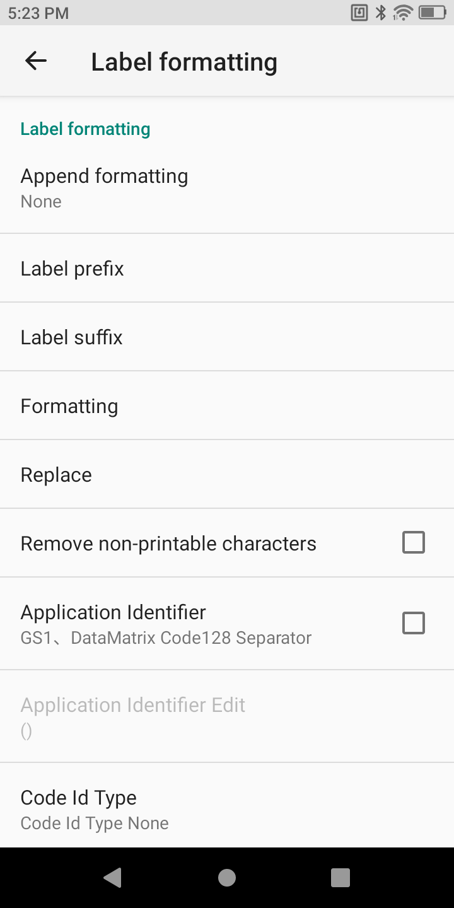

Figure 3-10 Bar Code Formatting Settings

1. Tap **Label Formatting** and select the Append formatting type;

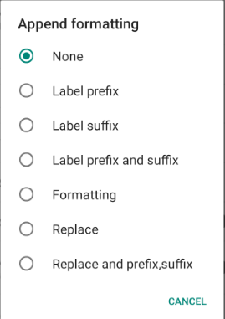

Figure 3-11 Formatting Type Settings

1. **Suffix**: select the mode and modify the suffix content, e.g., select [CR] which indicates enter;

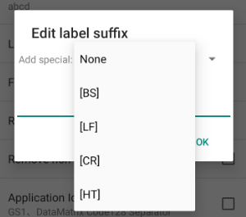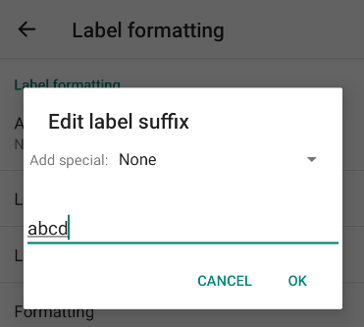

Figure 3-12 Edit Suffix

Select the default type from the drop-down list box or define any character as the prefix/suffix;

1. **Prefix**: select the mode and modify the prefix content, e.g., select [CR] which indicates enter;

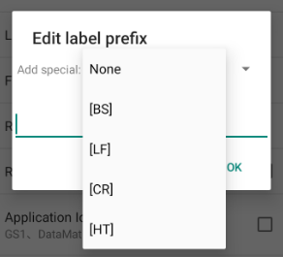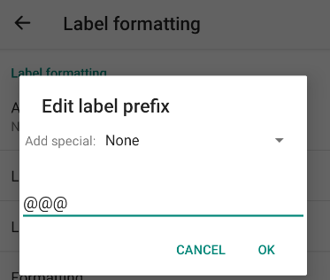

Figure 3-13 Edit Prefix

Select the default type from the drop-down list box or define any character as the prefix/suffix;

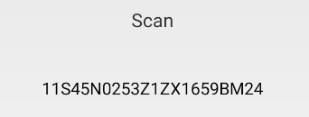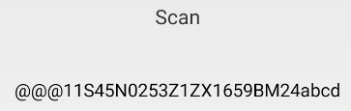

Figure 3-14 Test Prefix/Suffix

1. **Formatting**: select the mode and modify the content, e.g., select [CR] which indicates enter;

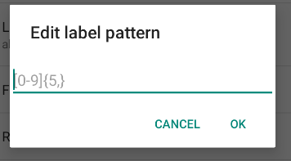

Figure 3-15 Edit Formatting

E.g.: Extract a longer section of bar code data

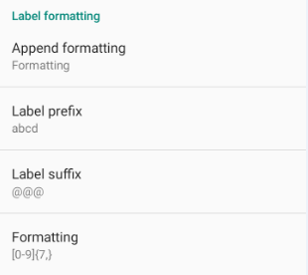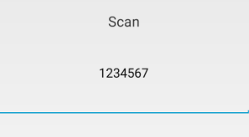

Figure 3-16 Example Result

Bar code formatting is required of input by regular expression, \d{7,} or [0-9]{7,} . Figure≥7 rather than ＜7

1. **Replace**: select the mode and modify the former character to be substituted and the substitute character and set the value of the substituted and that of substitute. The former character needs to be input in ASCII code (e.g., if the former character "1" needs to be substituted, enter its corresponding ASCII code value "31");

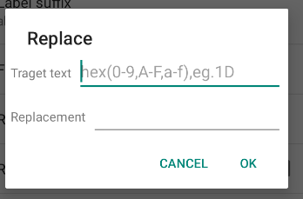

Figure 3-17 Edit Replce

1. Delete Non-printing Control Character: select the mode and delete any non-display character;
2. App Identifier: select the mode and add an app identifier to some bar codes, e.g., Code 128;
3. App Delimited Identifier: select the mode and set "()" as the app delimited identifier by default, which may be substituted by any other identifier;
4. Code Id Type: select the mode and add a Code Id (Code Id Type None, Code Id Type Aim (add an Aim in front bar codes) or Code Id Type Symbol (add an identifier in front of bar codes)) to some bar codes;

* Symbology settings

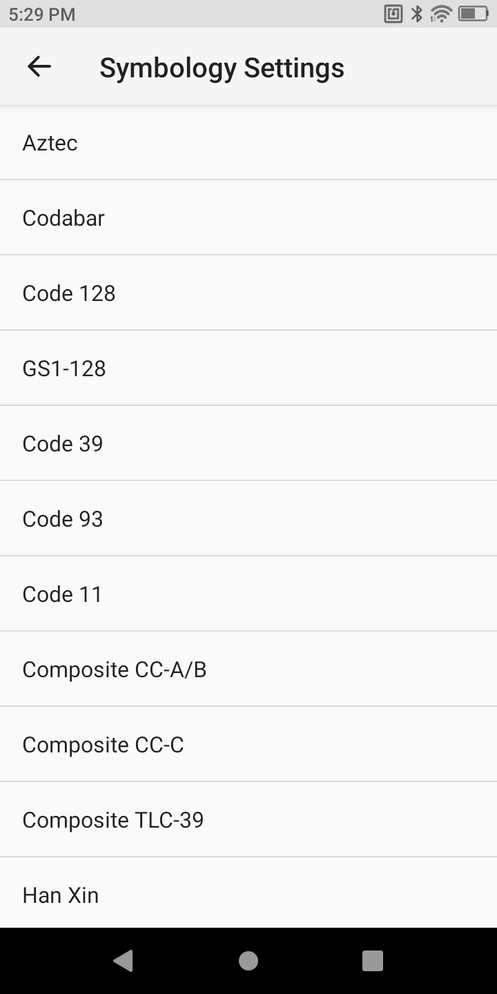

Figure 3-18 Bar Code Settings

* Modify code system type parameters in the list, e.g., bar code length, check bit or transfer character

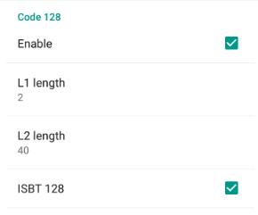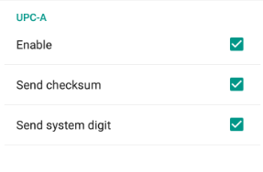

Figure 3-19 Code128 Settings Figure 3-20 UPC-A Settings

* Enable: enable
* L1 length: minimum length
* L2 length: maximum length
* ISBT128: book code
* Send checksum: check bit in transfer
* Send system digit: numeric character in transfer

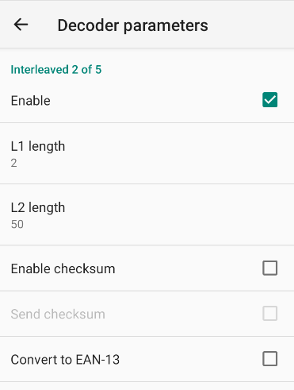

Figure 3-21 ITF Settings

Convert to EAN-13: transfer to EAN-13 code

* If parameters needed are not found in the settings, please contact the technical support for modification.
* Reset

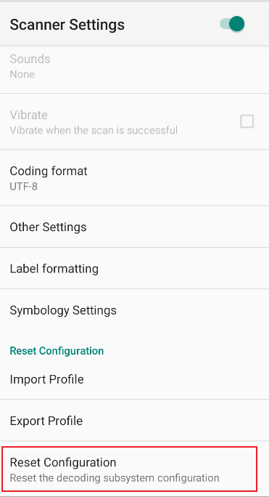

Figure 3-22 Reset

**Import Profile** - import all settings in the scanner_property.xml file saved in the /sdcard root directory;

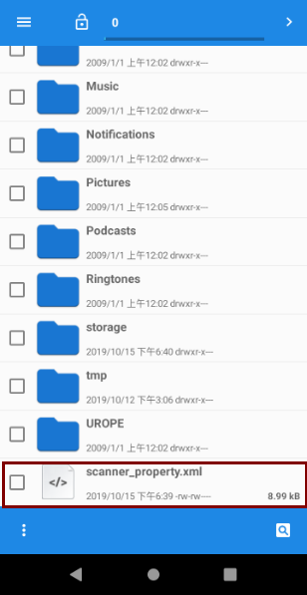

Figure 3-23 Scanner_property.xml File

**Export Profile**- export and save all set values in the current status in the scanner_property.xml file saved in the /sdcard root directory by default;

**Reset Scan Engine**: if the scan engine needs to be reset, click this function option and reset and restore the scan engine. This function applies despite any unreadable or code garbling situation in scanning.

# Chapter IV Wireless

### WLAN

To enable the WLAN function, please operate as following:

#### Connect to WLAN

After the wireless function is enabled, CF-H906 will automatically display all the available wireless networks nearby in the wireless network list. To connect to a certain wireless network, please click the network's SSID in the list and tap**Connect**.

Note: For some networks, network security key or password needs to be entered for connecting. To connect to such networks, please contact the network admin for corresponding network security keys or passwords.

1. Open Settings-WLAN or pull down the status bar to enter the quick access panel for operation;

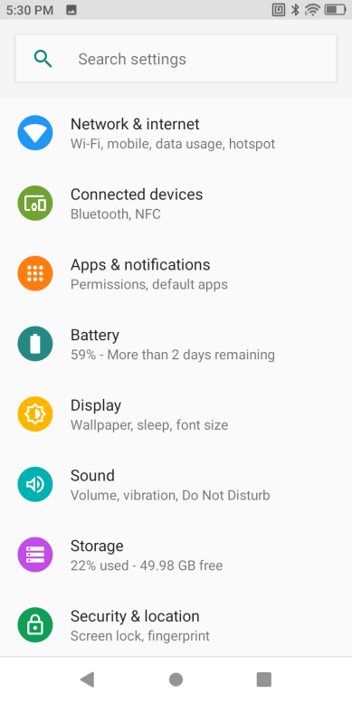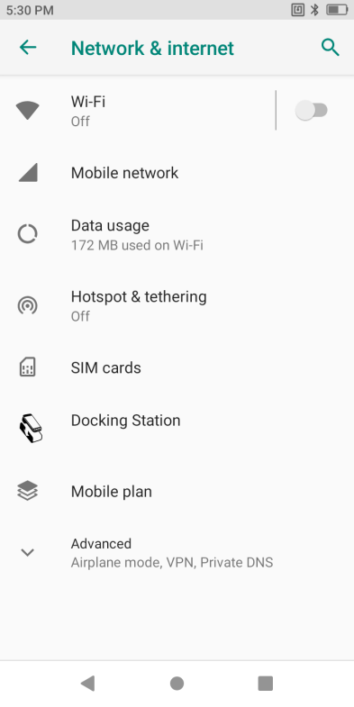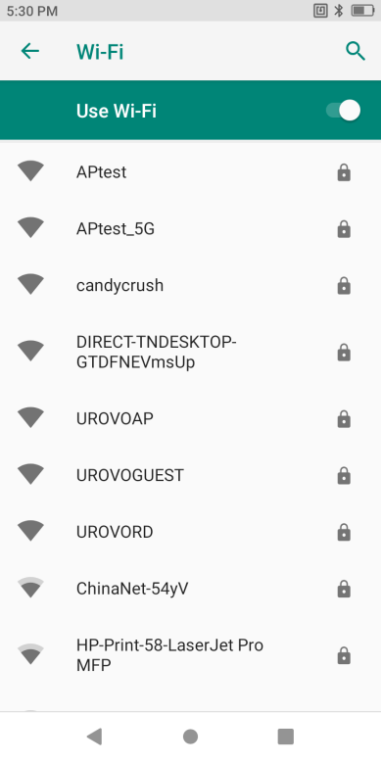

Figure 4-1 WIFI Option Bar

1. Touch to turn on the hotspot function;
2. Enter the password and tap "Connect"

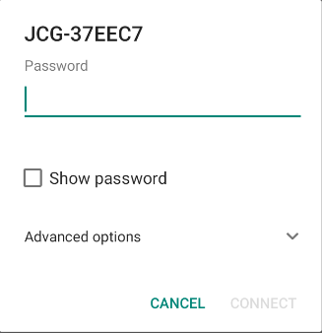

Figure 4-2 WIFI Password and Settings Input Box

* + - * Check **Show Password** to display the hotspot password to check whether the password input is wrong;
      * Check **Advanced Settings** for advanced settings, including agent and static IP settings.

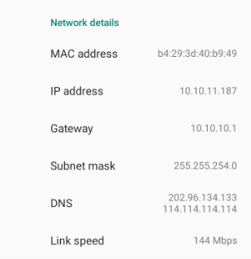

Figure 4-3 WIFI Static IP Settings

1. Check whether connection is done: 'Connected' indicates that connection is done

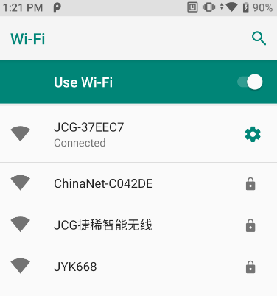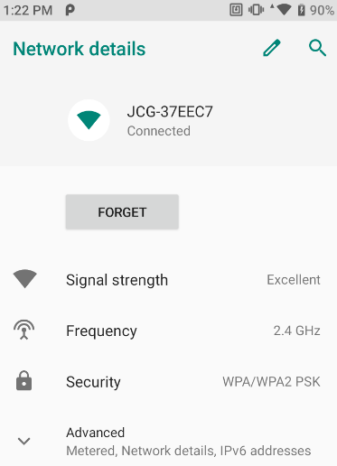

Figure 4-4 WIFI Connected

WLAN allows indoor wireless communication of CF-H906. CF-H906 supports WIFI in two frequency bands: 2.4G and 5G. WLAN security options support below protocols

* Open
* WEP
* WPA/WPA2 PSK
* 802.1x EAP
* WAPI PSK

### WWAN

Please refer to "Instruction on SIM/TF Card installation" for how to insert a SIM Card

Open "Settings"-"Network and Internet"-"Mobile Network" to set the mobile network in conjunction with carrier information settings, such as data on/off, roaming on/off, and access point name, etc.

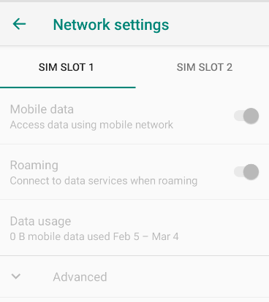

Figure 4-5 Mobile Network Settings

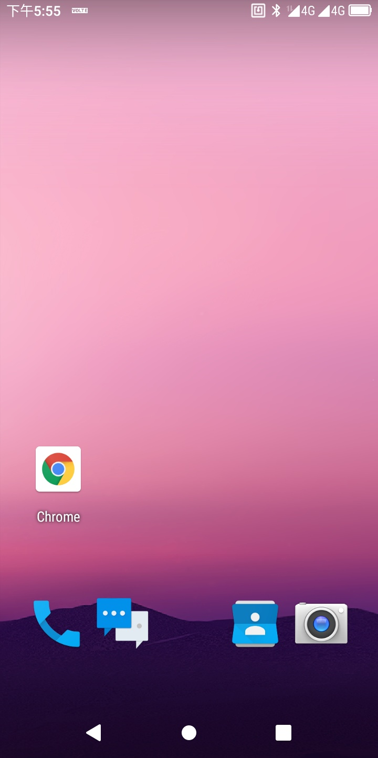

Figure 4-6 Mobile Network Icon

CF-H906 supports a wide range of 4G networks. If failed to connect to WWAN, please follow as below:



1）Check local network signal intensity;

2）Check whether the SIM Card is correctly installed;

3） Check whether the SIM Card has any pending bill, is available for surfing the Internet or damaged (test whether the SIM Card is damaged or has any pending bill by loading the SIM Card in the device);

4）Check whether the access point is correctly set.

### Bluetooth

Any device with Bluetooth is available for wireless communication to transmit and receive data by wireless radio frequency (2.4 GHz);Industrial, scientific and medical (ISM) by bandwidth (802.15.1). Bluetooth wireless technology is class 3, which is short range (10 m/32.8 feet) and low power consumption.

Device with the Bluetooth function such as printer, access point and other mobile computer can exchange data (e.g., file, date or task) after turning on the Bluetooth function.

CF-H906 supports BLE (Bluetooth low energy). BLE is oriented to healthcare, health, safety and home entertainment apps. It remains a standard Bluetooth coverage while reducing power consumption and saving cost.

Bluetooth connection

1. Pull down the status bar and long press the Bluetooth icon or click **Settings**-**Connected Device** to enter the page;
2. Tap**Device Name**canchange visible name to another.

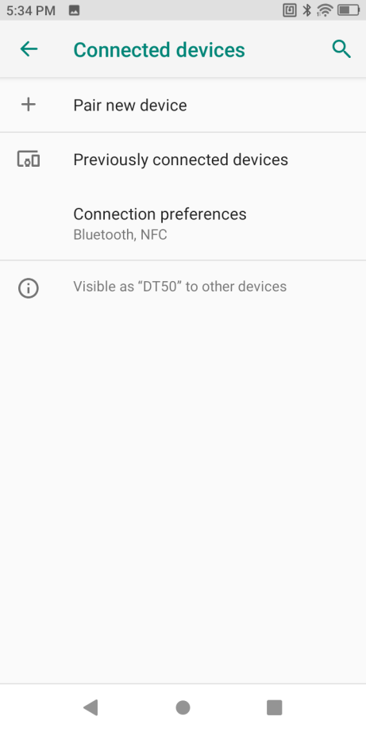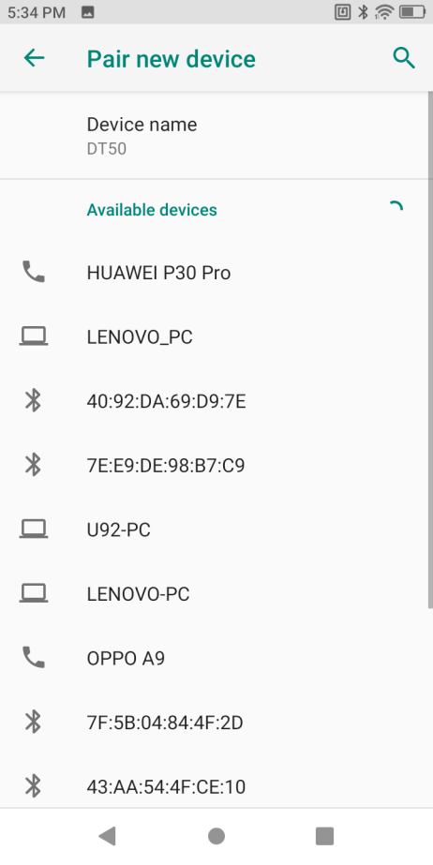

Figure 4-7 Bluetooth settings

1. Tap**Pair New Device** to search for Bluetooth devices nearby;
2. Tap the device to be connected and enter PIN code for verifying pairing or request for entering PIN code.

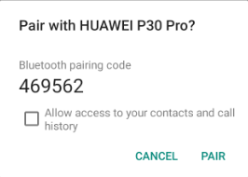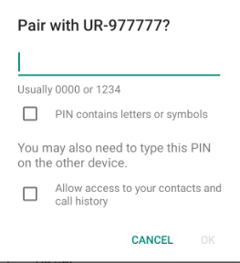

Figure 4-8 Bluetooth Pairing

1. Management paired devices
2. Pull down the status bar and long press the Bluetooth icon or click **Settings**-. Tap **Connected devices**" to enter the setting page;
3. Click **Previously connected Devices** to "Cancel Saving", "Connect" to operate.

# Chapter V RFID-UHF

### RFID SCAN

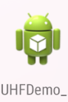

Click the RFID icon to enter the program connection interface, click connect to enter the main interface and start scanning, the default parameter for RFID tag scanning

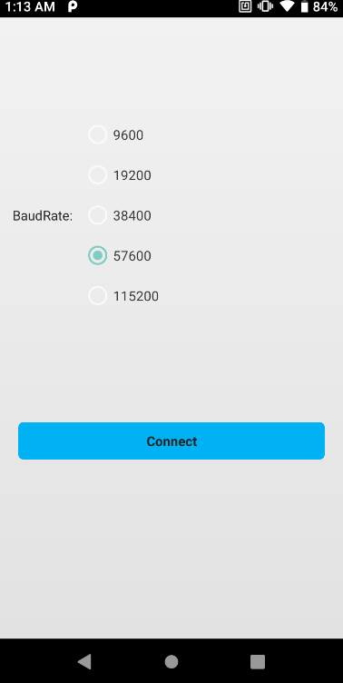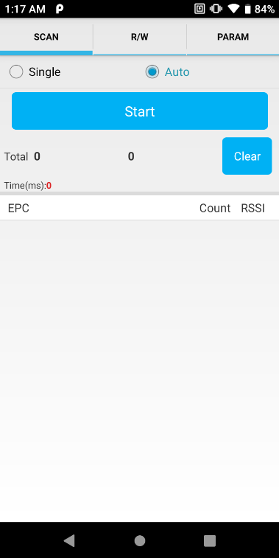

Figure 5-1Connect Figure 5-2Scan

The meaning of the data display is as follows:

|  |  |
| --- | --- |
| Total | First:The different Number  Second:The total number include the same |
| Time(ms) | The total elapsed time since clicking the Start button. |

The meanings of the fields in the tag list are as follows:

|  |  |
| --- | --- |
| EPC | EPC number of the label |
| Count | Number of times the label has been recognized |
| RSSI | The signal strength the last time the tag was recognized |

### Read/Write

**Read**: you need to enter four parameters: access password, memory, start address and data length.

It should be noted that the input parameters must meet the label specifications, otherwise an error message will appear, where the address and length are in decimal format, and the read/write data is in hexadecimal string format, and the length must be an integer of 4. Times.

**Write**: The difference in the write operation is that the write operation also needs to input the data to be written.

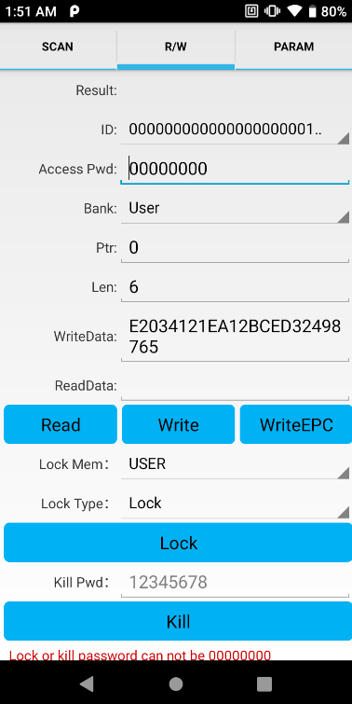

Figure 5-3Read And Write

### Lock

The lock tag must provide an access code to proceed.

*Note: The original password is invalid. It is recommended that the user modify the access password before locking the label.*

The write access password “12345678” operation is as follows:

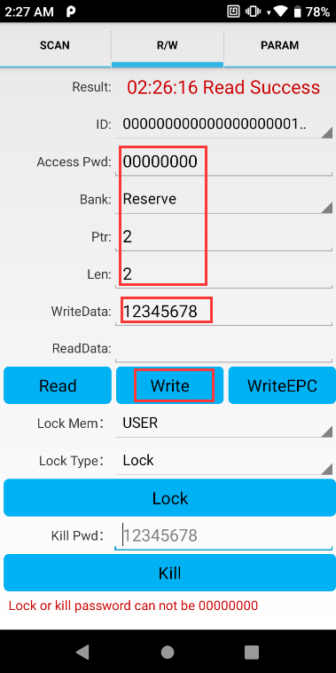

Figure 5-4Write Access password

After the operation is successful, you can use the new access password to lock

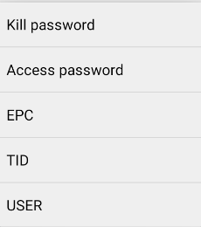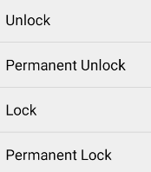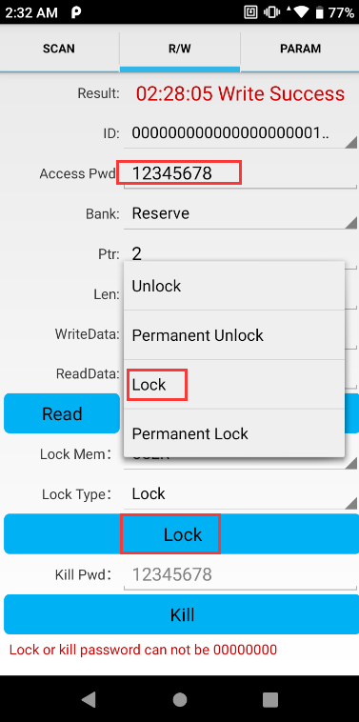

Figure 5-5Lock

### Kill

The operation interface of the destruction label is shown in the figure below

Destroy the label must provide an inactivation password, and the destruction password cannot be 00 00 00 00, so to destroy a label, you must first modify the content of the password area destruction password through the write label command.

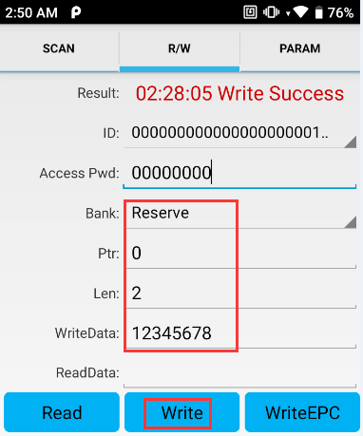

Figure 5-6Write Kill Password

After change kill password, enter the new password in the kill password box and click the kill button.

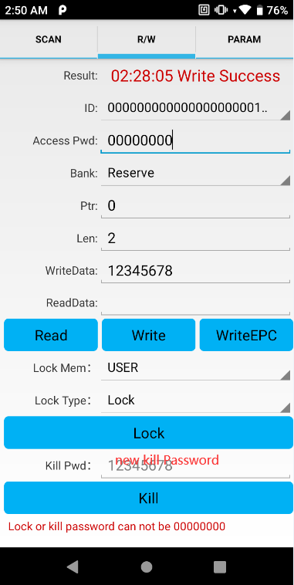

Figure 5-7Kill

### PARAM

PARAM tab, mainly to set the configuration of the reader

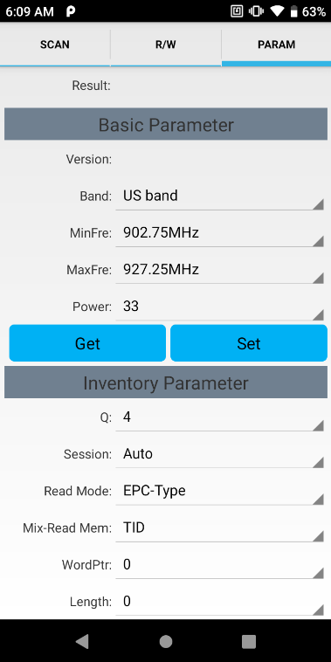

Figure 5-8Basic Parameter

Basic Parameter :set the frequency band and power of the UHF module

Inventory Parameter :set various parameters used in the inventory process

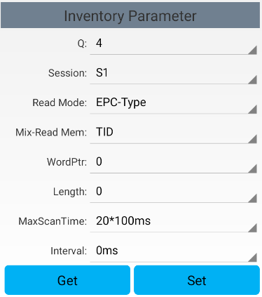

Figure 5-9Inventory Parameter

Basic Parameter：

1.Version: Firmware version

2.Band: Set the working frequency region

3.MinFre: Set the minimum frequency

4.MaxFre: Set the maximum frequency

5.Power: Set the working power.

Inventory Parameter：

1.Q：the original Q-value of the EPC tag inventory, the setting of Q-value should follow the rule: 2Q ≈ total amount of tags within the effective field. The range of Q-value is 0 ~ 15, if other value is delivered in this field, reader will return a parameter error status in the response frame

2.Session: the Session-value of the EPC tag inventory

3.Read Mode：EPC-Type，Only read the EPC；Mix-Type，read EPC and Memory

4.Mix-Read Mem： Read type of memory

5.WordPtr：read memory start Address

6.Length：Read memory length

7.MaxScanTime：the inventory time configuration for the current inventory. Reader will set the maximum operation time as ScanTime*100ms

8.Interval：After the last inventory command is executed, delay the time to start next inventorycommand

# Chapter VI Maintenance and Troubleshooting

### Introduction

This chapter sets forth the device's maintenance methods and troubleshooting solutions to help users use the product appropriately.

### Maintenance

To ensure that the device does not break down, please abide by the following instructions while using CF-H906:

• Do not scratch the screen of CF-H906. While using CF-H906, please use a recognized touch pen or any other pen which is fit for touching with point made from plastics. Please do not use a real pen, pencil or anything sharp to touch the screen of CF-H906.

• The screen of CF-H906 is made from glass. So please do not make CF-H906 fall on the ground or get hit.

• Prevent CF-H906 from bearing too high or low temperature. Do not put the device on any automotive instrument panel in hot weather. Keep it away from any heat source.

• Do not use CF-H906 anywhere dusty, dump or moist.

• Clean the scanning head and camera of CF-H906 by soft lens cloth. If the screen of CF-H906 gets dirty, please clean the screen by soft cloth with diluted glass cleaning solution.

#### CF-H906 cleaning

**Housing**

Scrub the housing by cloth with alcohol, including keys.

**Display screen**

Scrub the display screen by alcohol wipes but be sure that no liquid drops nearby the edge of the display. Immediately dry the display screen by soft and abrasive-free cloth to prevent mark left.

**Camera and scanning window**

Please scrub the camera and scanning window by lens wipers or other materials made for cleaning optical materials (e.g., glasses).

### Troubleshooting

CF-H906 troubleshooting

|  |  |  |
| --- | --- | --- |
| Problem | Reason | Solution |
| Press the power key but CF-H906 does not work. | The battery is not charged. | Charge the battery in CF-H906. |
| The system crashes. | Execute resetting. |
| The battery is not charged. | The battery breaks down. | Replace the battery |
| The battery's temperature is exceptional. | Contact for technical support |
| During data communication via Wi-Fi, no data are transferred or not all data are transferred. | Wi-Fi communication is not enabled. | Turn on Wi-Fi communication. |
| The device is out of the range of the access point. | Move closer to the access point. |
| During data communication via Bluetooth, no data are transferred or not all data are transferred. | Bluetooth communication is not enabled. | Turn on Bluetooth communication. |
| The device is out of the signal range of another Bluetooth device. | Move within 10m (32.8ft) range of another device. |
| No sound. | Volume setting is too low or turned off. | Adjust volume. |
| CF-H906 is off. | CF-H906is at inactive state. | Not use for a while, the display will automatically turn off. Set the duration to be longer, such as 15 s, 30 s, 1 min, 2 min, 5 min, 10 min or 30 min. |
| The device runs out of battery. | Charge the battery. |
| Tapping a window button or icon  but fail to trigger the corresponding function. | The device does not respond. | Reset the device. |
| A message pops up, indicating that CF-H906's storage is full. | Too many files are saved in CF-H906. | Delete unused memos and records. If necessary, save such records in the host (or use SD Card as additional memory). |
| Too many apps are installed in CF-H906. | Uninstall unused apps in CF-H906 to recover storage capacity. |
| CF-H906 fails to decode while reading a bar code. | The bar code is unreadable. | Check the barcode is not damaged. |
| The distance between the laser scanning window and bar code is wrong. | Put CF-H906 within proper scanning range. |
| The bar code type is not checked, or bar code length is wrong. | SetCF-H906 to accept the scanned bar code type. |
| Battery low. | Check battery capacity. |